Section 1.7: Continuity and One-Sided Limits

One Sided Limits

Example 1: Evaluate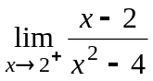.

Solution:

█

Example 2: Evaluate 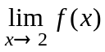 if 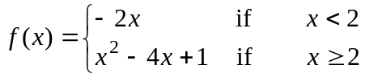

Solution: We evaluate the left and right limits as follows:

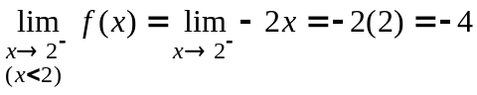

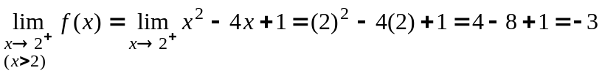

Since the left and right limits are not equal, that is, since,

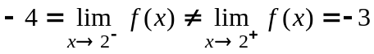

We conclude that does not exist.
█
Continuity

A function is continuous if there are no jumps, breaks, or holes in the graph.

x
y

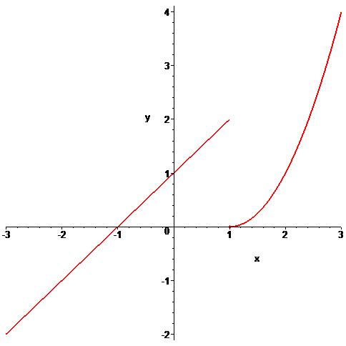

Formal Definition of Continuity

A function f is continuous at x = a if

1. 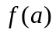 exists
2. 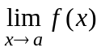 exists
3. 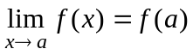

Note:

1. A function is continuous from the left if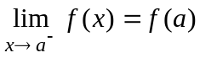.
A function is continuous from the right if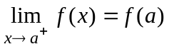.
A function is continuous in general if.

2. A function that is not continuous at a point is said to be discontinuous at that point.

3. A discontinuity is removable if we can remove the discontinuity by redefining f at a
single number (look for a discontinuity with a single hole in the graph). This normally
occurs when the first two conditions of continuity are satisfied but 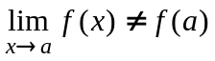.
The discontinuity can be removed by redefining the function at x = a where

Example 3: Given
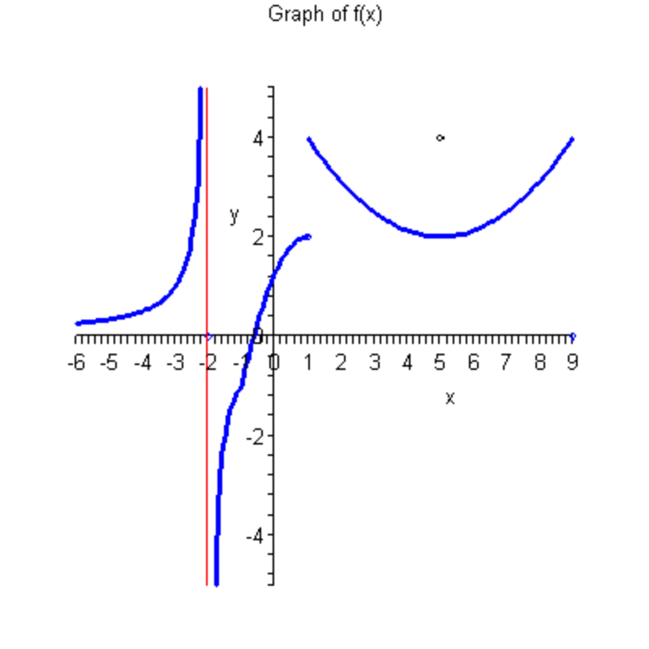
a. Determine the points where f is not continuous.

b. Which of the discontinuities are continuous from the left? The right? Neither.

c. Which discontinuity is removable?
d. Specify the intervals where the function is continuous.

█

Example 4: Use the definition of continuity to determine if the function 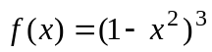 is continuous at a = -1.

Solution:

█
Example 5: Use the definition of continuity to determine which x values that the function 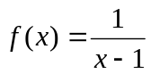 is not continuous. Is the discontinuity removable?

Solution:

█

Example 6: Use the definition of continuity to determine which x values that the function

is not continuous. Is the discontinuity removable?

Solution: For a piecewise function such as this, values of x where the function is not continuous occur at values of x where the formula of the function changes. For this function, this occurs at x = 2. We see if this function passes the three part definition of continuity at this point.

1. We first determine if 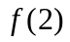 exists. Since 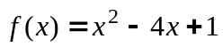 when x = 2, we have

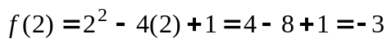

Thus, exists and the first criteria is satisfied.

2. We next see if 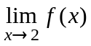 exists. From example 2, we saw that

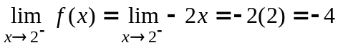

Since,

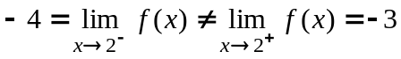,

does not exist.

Since does not exist, criteria 2 for  to be continuous fails. Hence,
is not continuous at x = 2.

Since does not exist, there is not a way to redefine where
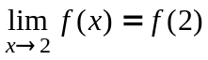. Thus, the discontinuity is not removable. █
The following represents the graph of in the previous example, where the discontinuity can be seen at x = 2.

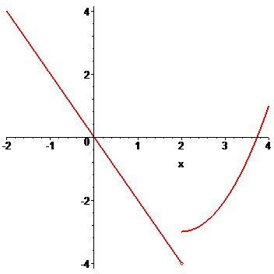

Example 7: Use the definition of continuity to determine which x values that the function

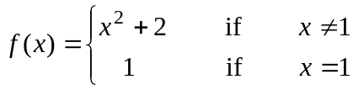

is not continuous. Is the discontinuity removable?

Solution:

█

Greatest Integer Function

Fact: The notation 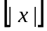 represents the largest integer n such that 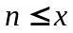. For example,

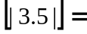 and 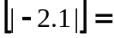

Note: The greatest integer function 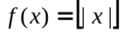 is not continuous for any integer.

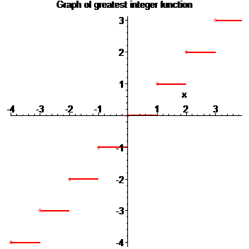
Example 8: For what value of the constant c is the function f continuous on 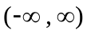
where

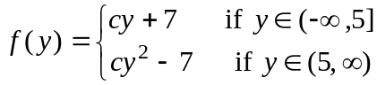

Solution:

█

Example 9: The function f is given by the formula 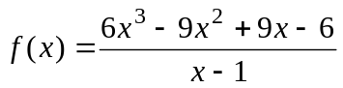 when 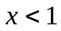 and by the formula 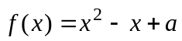 when 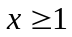. What value of a must be chosen to make this function continuous at 1?

Solution: To be continuous, first the function must exist at 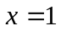, that is, 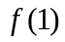 must be defined. For this function

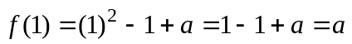.

Thus, exists. Next, we must show that 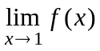 must exist, which is true if the left and right limits equal the same numerical value. Now

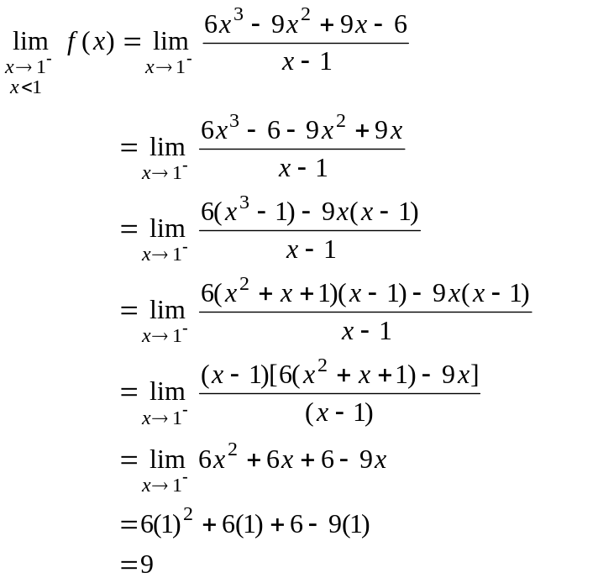

Also, 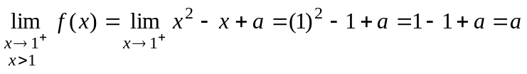.

Hence, in order for 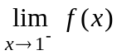 and 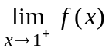 to be equal, 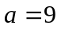. If , then the 3rd condition of continuity will be true, that is

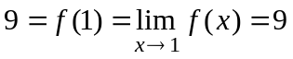
Hence, the function is continuous if .

█

