Section 1.5: Finding Limits Graphically and Numerically

Limits

Consider the function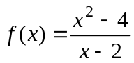. Note that x = 2 is not in the domain of f.

Consider the table.
x | 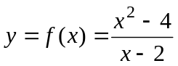
1
1.5
1.9 | 3.9
1.99 | 3.99
1.999 | 3.999
1.9999 | 3.9999
2 | undefined
2.0001 | 4.0001
2.001 | 4.001
2.01 | 4.01
2.1 | 4.1
2.5 | 4.5
3 | 5

For values of x < 2:

For values of x > 2:

Limits – Informal Definition

A function f has a limit L as x approaches a, written as

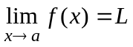

if we can make the values of  as close to L as we like by taking x to be sufficiently close to a (to the left and right of a) but not equal to a.

Note: 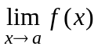 can exist if 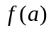 does not exist.

Example: Consider the fact that 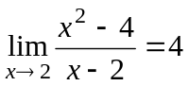 even though for , 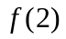 does not exist.

Facts About Limits

For the limit to exist, the left and right limits must have equal numerical values.

Notation: 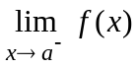 indicates the limit from the left.

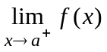 indicates the limit from the right.

For the limit to exist,

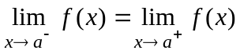

Example 1: Given the graph of .
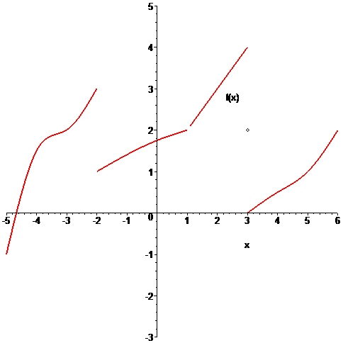
Find

a. 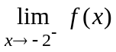

b. 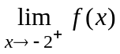

c. 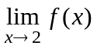

d. 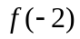

e. 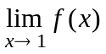

f. 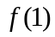

g. 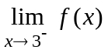

h. 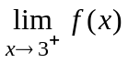

i. 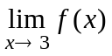

j. 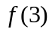
Example 2: Evaluate the function 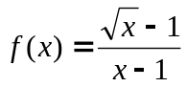at the numbers x = 0.5, 0.7, 0.9, 0.99, 0.999, 1.001, 1.01, 1.1, 1.2, 1.5 and use the result to estimate 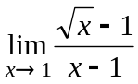

Solution: The following table demonstrates the functional or y-values for the given x values.

x | 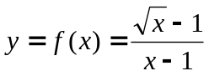
0.5 | 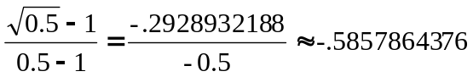
0.7 | 0.5444665783
0.9 | 0.5131670190
0.99 | 0.5012562900
0.999 | 0.5001251000
1 | undefined
1.001 | 0.4998750000
1.01 | 0.4987562000
1.1 | 0.4880884800
1.2 | 0.4772255750
1.5 | 0.4494897420

In both cases, the left and right limits appear to be approaching 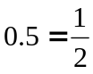 and x gets closer to 1 from both the left and right. Thus, we conclude that

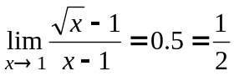

█

Example 3: Use a graphics calculator or Maple to find 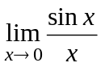

Solution: The following Maple command produces the graph of this function

> plot(sin(x)/x, x = -5..5, y = -2..2, thickness = 2, color = red, title = "Graph of sin(x)/x");

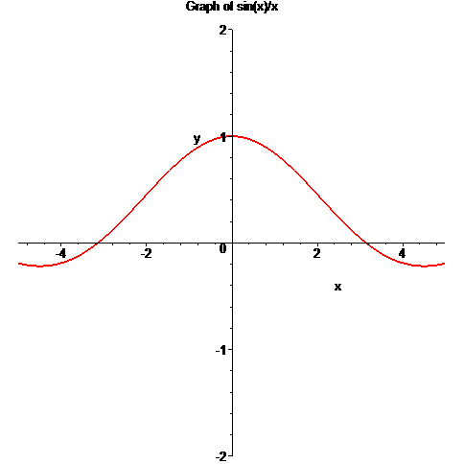

█
Example 4: Use a graphics calculator or Maple to find 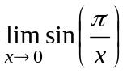

Solution: The following Maple command produces the graph of this function

> plot(sin(Pi/x), x = -2..2, y = -2..2, thickness = 2, color = red, title = "Graph of sin(x)/x");





