Section 1.2: Functions and Their Graphs

Interval Notation

Interval Notation provides a shorthand way of representing particular sets on the real number line. Many of the answers for the problems given in your textbook use interval notation. We review some of the basic intervals.

- Closed Interval: 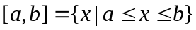 represents all numbers between and including
the endpoints a and b.

Graphical Representation:

x
- Open Interval: 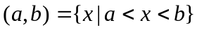 represents all numbers between a and b not including a and b.

Graphical Representation:

x

- Half Open Interval: 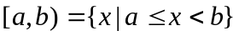

x

- Unbounded Intervals:

- 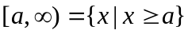
x

- 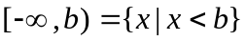
x

- 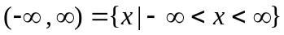
x
Example 1: Write the inequalities 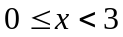 and 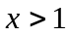 in interval notation.

Solution:

█

Functions

Definition: A function is a rule that assigns to each number x in one set (called the domain of the function) a unique (one and only one) number y in another set (called the range).

Notation: A function is represented by 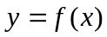.

Note: Graphically, the functional value  gives the y coordinate of the ordered pair
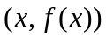corresponding to the input value x.

Informally, we define the domain and range of a function as follows:

Domain - the set of x values (inputs) of which a function is defined.
Range – set of y values output by the function.

Representing Functions Graphically

Example 2: Given the following graph of a function:

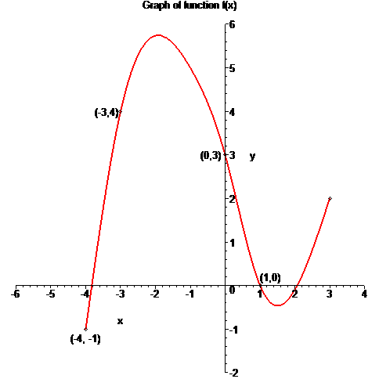
Answer the following:

a. Find 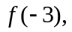 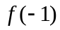 and 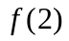
b. For what values of x does 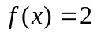?
c. State the domain and range of f.

Solution:

█
Representing Functions Algebraically

Example 3: Given 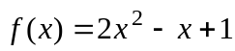. Find

a. 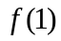
b. 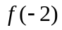
c. 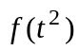
d. 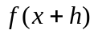
e. 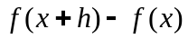
f. 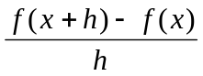

Solution:

█
Finding the Domain of a Function Algebraically

Recall that the domain of function is the set of input (x values) for which a function is defined or makes sense. We demonstrate how to determine the domain of a function algebraically in the next few examples.
Example 4: State the domain of the function 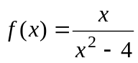.

Solution:

█

Example 5: State the domain of the function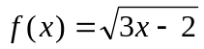.

Solution: For this problem, the domain must be values of x that, when input, give a non-negative term under the square root. Thus, we solve the inequality

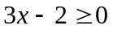

Adding 2 to both sides solves this inequality and dividing by 3 (note, dividing by a positive number does not change the sign of the inequality) gives.
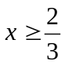

Thus, the domain is the following:

Domain: 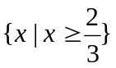 or in interval notation this answer is 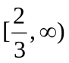
█
Example 6: State the domain of the function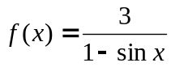.

Solution: The domain of this function will be restricted for values of x where the denominator of this function is equal to zero, that is, where

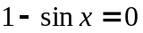

Solving this equation for x gives

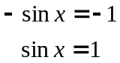

Now, one angle value were 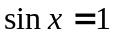 is 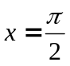. However, the sine function is periodic, which means there is an infinite number of solutions to this equation. Since the period of the sine function is 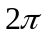, we can express the solution in terms of integer multiples of , that is

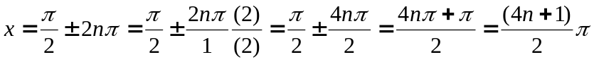

Thus, all solutions can be expressed by the formula. Thus, the domain is the set:

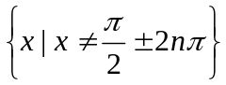 or 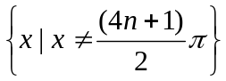

█

Example 7: State the domain of the function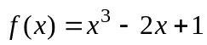.

Solution:

█
Piecewise Functions

Piecewise functions are functions that have different output formulas for different parts of the domain.

Example 8: Given the piecewise function 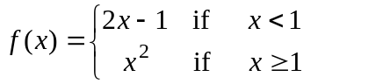
a. Find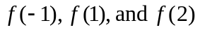
b. Sketch the graph.

Solution:

Note: Not all equations represent that of a function.

Vertical Line Test: a graph is that of a function if no vertical line touches the graph more than once.

Example 11: Determine whether the following graphs represent functions.

x
y
x
y
Composition of Two Functions

The composition of two functions f and g is denoted by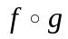. The composition 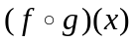
takes an input value x, performs g on this input to obtain 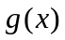, then performs f to obtain 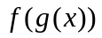.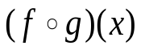
x
g(x)
f (g(x))

Example 12: Given

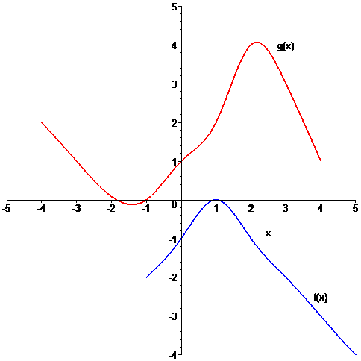

Find:
a. 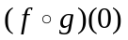
b. 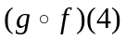

Solution:

█
Note: Algebraically, to compute 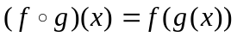, substitute the function for every occurrence of x in the function f.

Example 13: For the functions 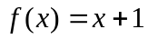 and 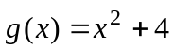, find
a. b. 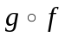

Solution:

█

Example 14: For the functions 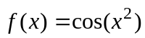 and 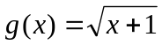, find
a. b.

Solution: We calculate these two compositions as follows:

Part a:

Part b:

█

