Additional Supplement Problems Trigonometry
Reference Angles
The reference angle is an angle between 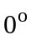 and 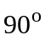 (0 and 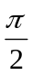 in radian measure) formed by the terminal side of the given angle and the x-axis.
x
y

Example 1: Find the reference angles for the angles 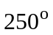 and 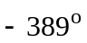.
Solution:

█
Example 2: Find the reference angles for the angles 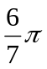 radians and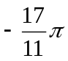 radians.
Solution:

█
Defining the Trigonometric Functions in Terms of Ordered Pairs

For the right triangle
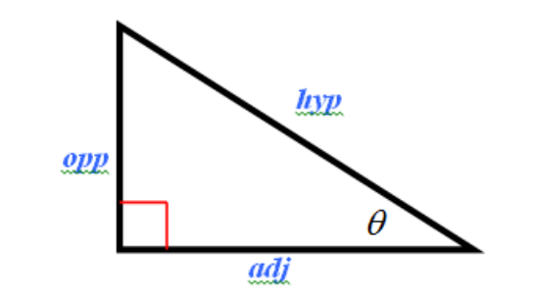
recall that the the Pythagorean Theorem says that 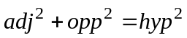 and that
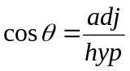 and 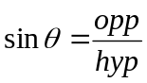
We can use this idea to define the cosine and sine functions, and hence all six trigonometric functions, for any point on the x-y coordinate plane as follows.
Suppose we are given the following diagram
x
y

We define the following six trigonometric function in terms of the ordered pair (x, y):
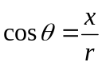, 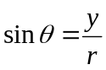, 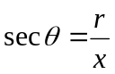, 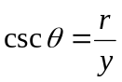, 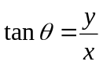, 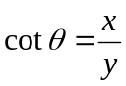
We illustrate this idea in the next examples.
Example 3: If 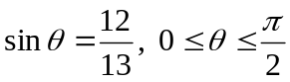, find 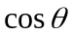, 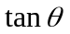, and 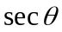.
Solution

█

Example 4: If 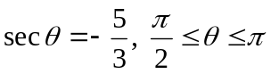, find 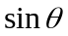, , and 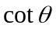.
Solution

█

Example 5: If 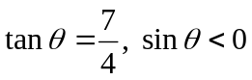, find , , , 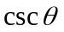, and .
Solution:

█

Recall that given and 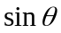,
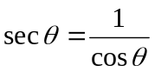, 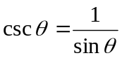, 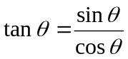, 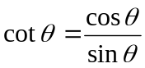
and
Pythagorean Identities
1. 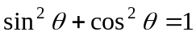
2. 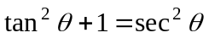
3. 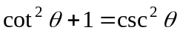
We can use these identities to simplify certain trigonometric expressions.
Example 6: Write each expression in terms of sines and/or cosines and simplify
a. 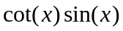
b. 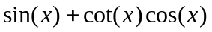
Solution:

█

Example 7: Write each expression in terms of sines and/or cosines and simplify
a. 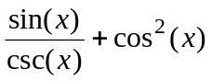
b. 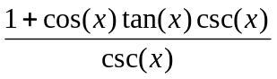
c. 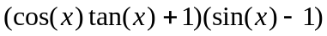

Solution:

█
Amplitude, Period, and Phase Shift for the Sine and Cosine Functions
Recall the graph of 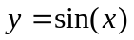 and 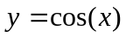
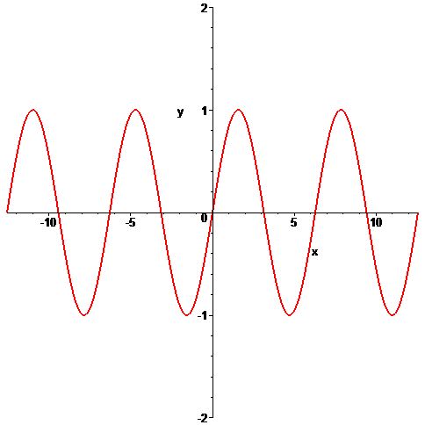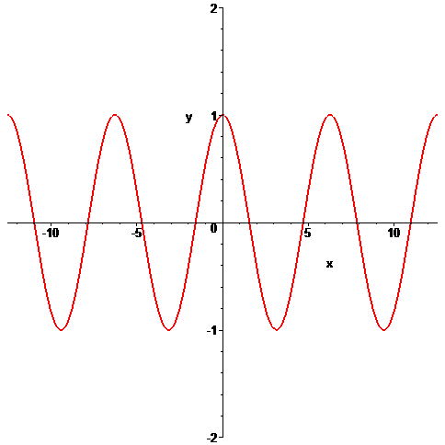
We can use this graph to graph related sine functions
The sine and cosine functions can be expressed in the general form as
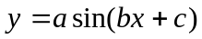 and 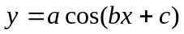
To make functions of these forms easier to graph, we define the following terms.
- Amplitude – gives the highest and lowest points of oscillation for the sine and cosine function. The amplitude is given by the 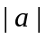
- Period – smallest value on which the sine and cosine function repeats itself. The formula for the period is given by 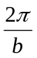.
- Phase shift – the amount on the x-axis the graph of the given sine and cosine function is shifted horizontally from the graph of the standard graphs of and . To find the phase shift, set 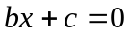 and solve for x. The value of 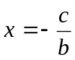 gives the phase shift amount.
Example 8: Determine amplitude, period, and phase shift for
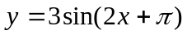
Solution:

█

Example 8: Determine amplitude, period, and phase shift for
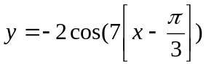
Solution:

█

