Math 142
Graph Theory Review
Spring 2013

Part I: Given the graph below, use Kruskal’s Algorithm to find the minimum spanning tree to connect each home (node) with fiber optic cable to provide instant access movies. Given each value represents thousands of dollars in cost (material and labor) to connect a cable to each of the homes what is the total cost (in thousands of dollars) to a company to connect each home to the movie network?

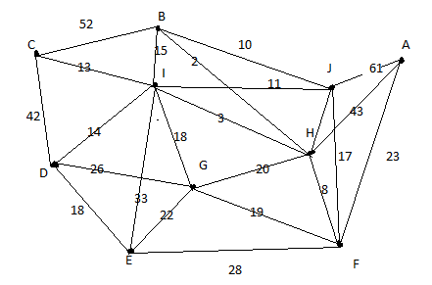

Draw your network here and provide the total cost.

Part II: You are a technician whose responsibilities are to service computer networks for a firm in Florida. The firm has offices in the cities listed below. You live in Orlando. Given the distances from Orlando to each office you are to visit monthly, answer the following questions about your Hamilton Circuit possibilities.

City | Fort Meyers | Jacksonville | Key West | Orlando | Pensacola | Tallahassee | Tampa
Fort Meyers | --- | 312 | 279 | 171 | 589 | 397 | 130
Jacksonville | 312 | --- | 507 | 141 | 355 | 164 | 198
Key West | 279 | 507 | --- | 387 | 821 | 627 | 402
Orlando | 171 | 141 | 387 | --- | 451 | 257 | 84
Pensacola | 589 | 355 | 821 | 451 | --- | 193 | 459
Tallahassee | 397 | 164 | 627 | 257 | 193 | --- | 273
Tampa | 130 | 198 | 402 | 84 | 459 | 273 | ---

How many possible routes exist (Hamilton circuits) for you to choose from?

How many unique routes exist (Hamilton circuits) for you to choose from?

Using the nearest neighbor algorithm, what would be an efficient route so you can visit each office in each Florida city, and how many miles would you travel to visit each city?

Name your route here:

List your total mileage here:

Part III: For graph given, answer the following questions below.

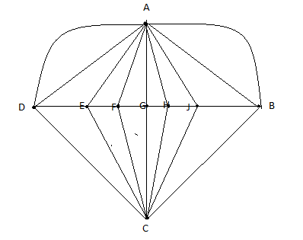

How many nodes exist?

How many edges exist?

What is the sum of the degrees of the nodes?

Does the graph have an Euler Circuit? Why or why not?

Does the graph have an Euler Path? Why or why not?

If the graph does not have an Euler Circuit, what edges could you add to the graph so an Euler Circuit would exist?

