Section 6.4: Partial Fractions

Practice HW from Larson Textbook (not to hand in)
p. 399 # 1-19 odd

Partial Fractions

Decomposes a rational function into simpler rational functions that are easier to integrate. Essentially undoes the process of finding a common denominator of fractions.

Partial Fractions Process
1. Check to make sure the degree of the numerator is less than the degree of the
denominator. If not, need to divide by long division.
2. Factor the denominator into linear or quadratic factors of the form

Linear: 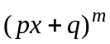 Quadratic: 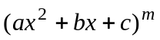

3. For linear functions:

where

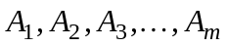 are real numbers.

4. For Quadratic Factors:

where 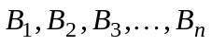 and 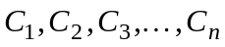.

Integrating Functions With Linear Factors Using Partial Fractions

1. Substitute the roots of the distinct linear factors of the denominator into the basic equation (the equation obtained after eliminating the fractions on both sides of the equation) and find the resulting constants.
2. For repeated linear factors, use the coefficients found in step 1 and substitute other
convenient values of x to find the other coefficients.
3. Integrate each term.

Example 1: Integrate 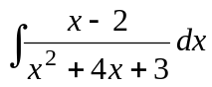

Solution:

█

Example 2: Integrate 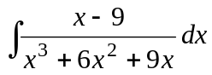

Solution: Note that the denominator

and hence the linear factors has roots of 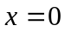 and 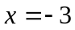. We perform the partial fraction expansion as follows:

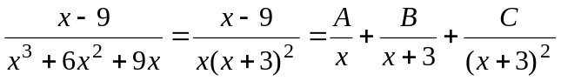

To eliminate the fractions and obtain the basic equation, we multiply both sides by 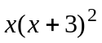 and obtain

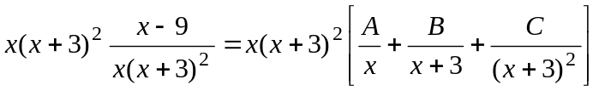

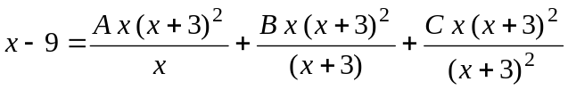

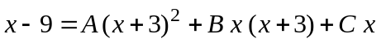 (Basic Equation)

To find A and C, we substitute the roots of the linear factors, x = 0 and x = -3, of the denominator into the basic equation. This gives

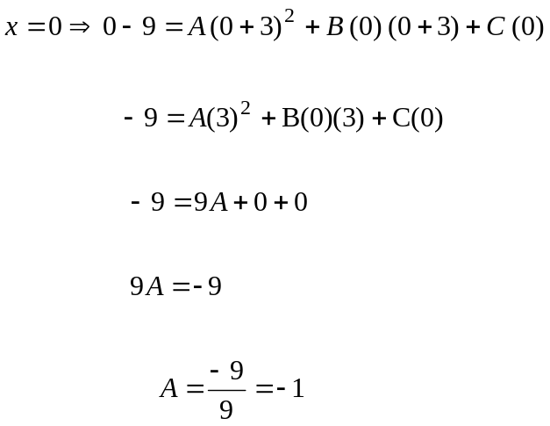
(continued on next page)
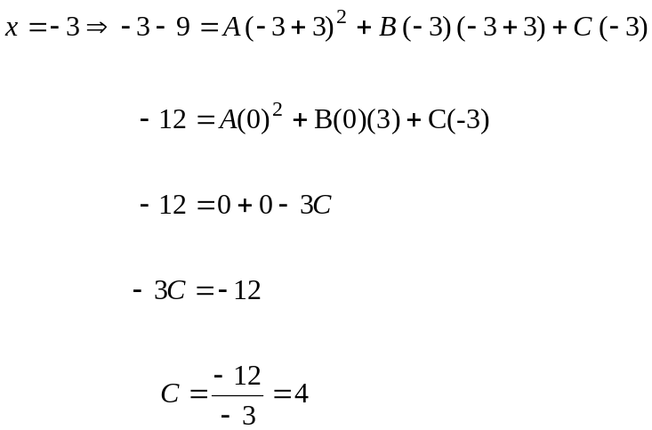

The basic equation is defined for all values of x. To find B, since we only have linear factors, we can choose a random value of x to substitute into the basic equation. An easy value to choose is 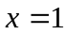. This gives

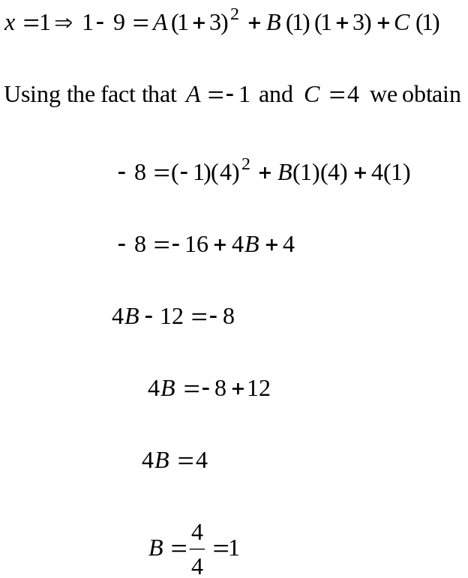

Substituting A = -1, B = 1, and C = 4 into

(continued on next page)
gives

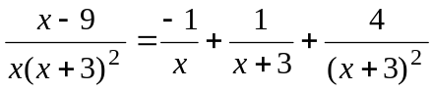

or

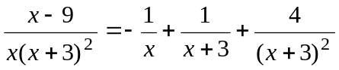.

Integrating, we obtain

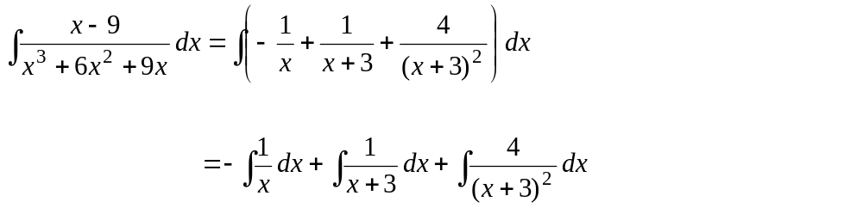
Let u = x+ 3 u = x+ 3
du = dx du = dx

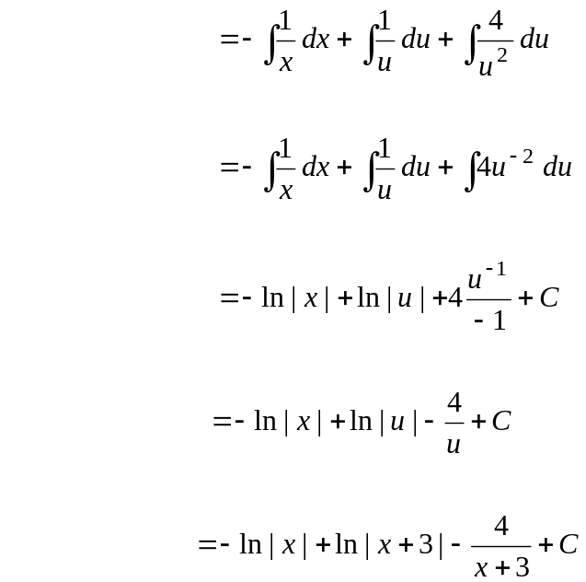

█
Integrating terms using Partial Fractions with Irreducible Quadratic Terms 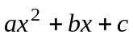 (quadratic terms that cannot be factored) in the Denominator.

1. Expand the basic equation and combine the like terms of x.
2. Equate the coefficients of like powers and solve the resulting system of equations.
3. Integrate.

Example 3: Integrate 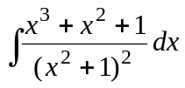

Solution:

█

Example 4: Integrate 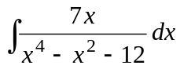

Solution: Note that the denominator

and hence the roots of the linear factors are x = -2 and x = 2. We perform the partial fraction expansion as follows:

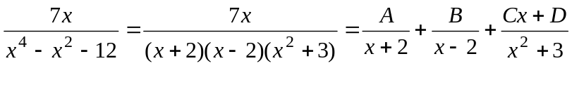
To clear the equation of fractions and obtain the basic equation, we multiply both sides of this equation by 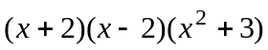. This gives

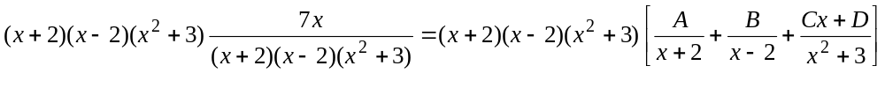

(Basic Equation)

To find A and B, we substitute the roots of the linear factors, x = 2 and x = -2, of the denominator into the basic equation. This gives

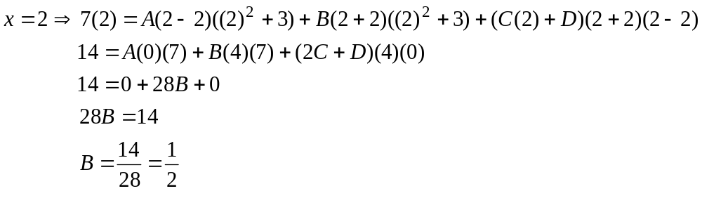
(Continued on Next Page)
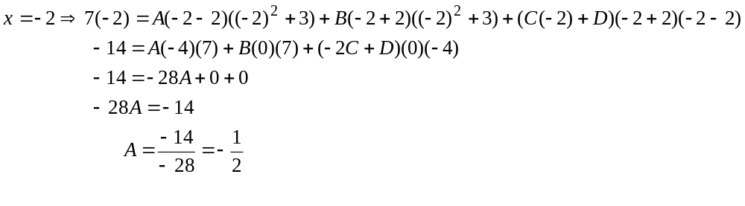
To find C and D, we must substitute the values of A and B we found into the basic equation, multiply out, and equate like coefficients.

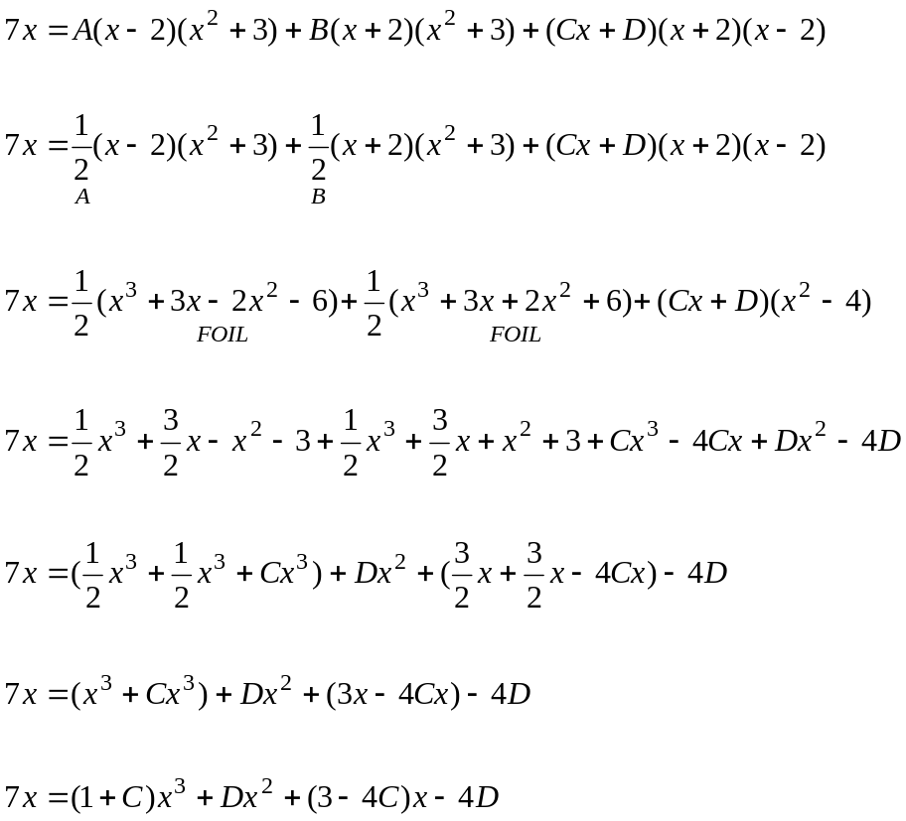

We write the equation in the following form and equate like coefficients.

(Continued on Next Page)

Equating like coefficients gives

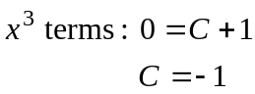, 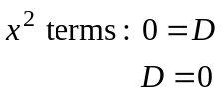, 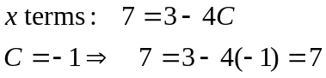, 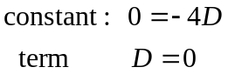

Substituting 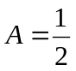, 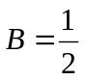, 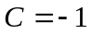, and 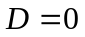 into

gives

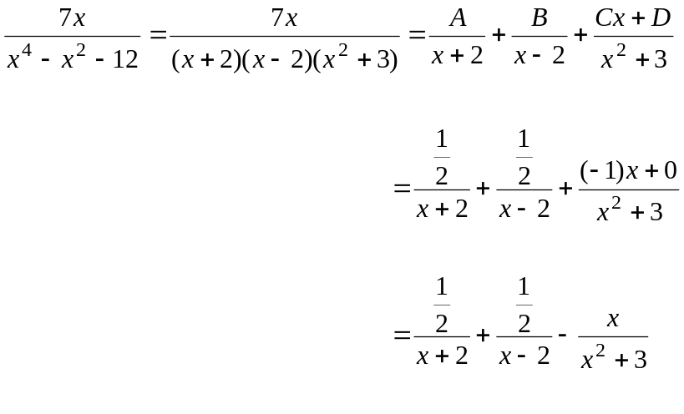

(Continued on Next Page)

Integrating, we obtain
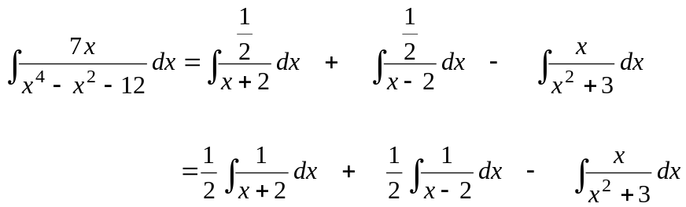
Let u = x+ 2 u = x- 2 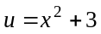
du = dx du = dx 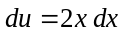
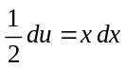

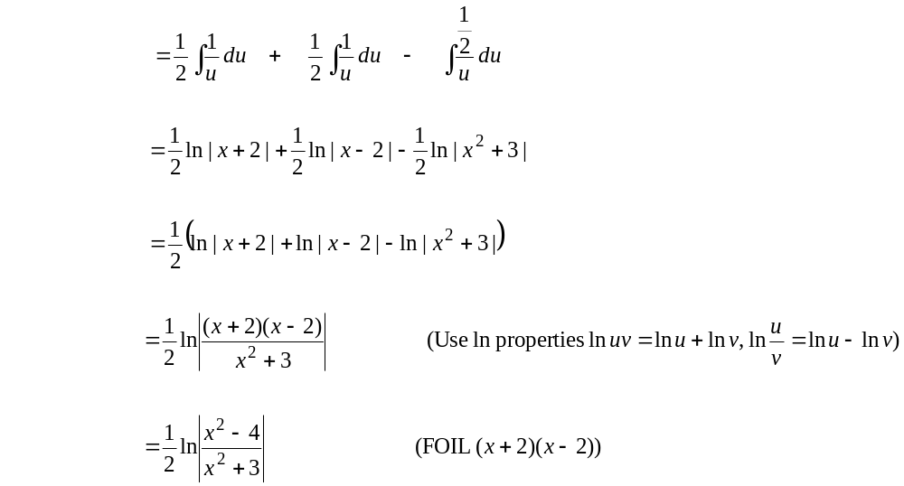

█
Example 5: Find the partial fraction expansion of

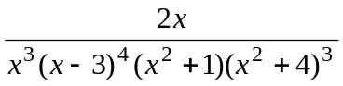

Solution:

█

Integration Technique Chart

Basic
Formula
u-du Substitution: Look for term to set u = to whose derivative similar to another term
Terms Multiplied No Denominators
Integration by Parts
Sine and
Cosine Integral Techniques
Trig Substitution
Partial
Fractions
Sine anc Cosine Powers
Radicals
Fractional
Expressions
Function to
Integrate

