Section 4.4: The Fundamental Theorem of Calculus

Practice HW from Larson Textbook (not to hand in)
p. 257 # 5-35 odd, 43-47 odd, 73-77 odd

Definite Integral

The definite integral is an integral of the form

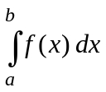.

This integral is read as the integral from a to b of 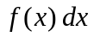. The numbers a and b are said to be the limits of integration. For our problems, a < b.

Definite Integrals are evaluated using The Fundamental Theorem of Calculus.

Fundamental Theorem of Calculus

Let  be a continuous function for 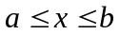 and 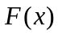 be an antiderivative of . Then

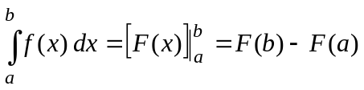

Example 1: Evaluate 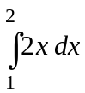.

Solution:

█
Example 2: Evaluate 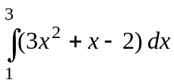.

Solution:

█

Additional Integration Formulas

1. 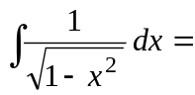

2 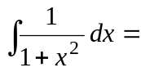

Example 3: Evaluate 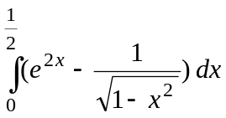.

Solution:

█
Example 4: Evaluate 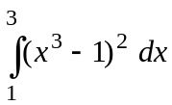.

Solution:

█

Example 5: Evaluate 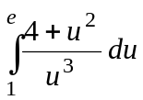.

Solution: We rewrite and evaluate the integral as follows:

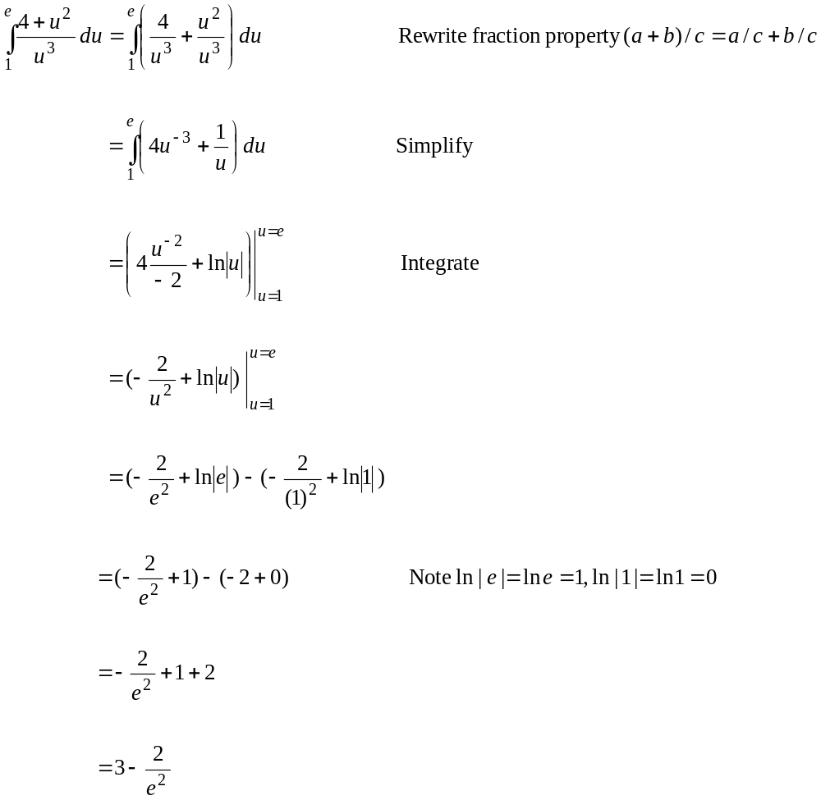
█

Example 6: Evaluate 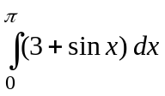.

Solution:

█

Recall that if 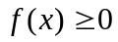 for . Then

Definite Integral: 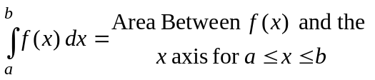

Example 7: Find the area under the graph of 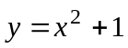 on [0, 2].

Solution:

█
Example 7: Evaluate 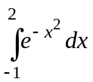.

Solution: On this one, there is no anti-derivative formula to integrate the function 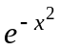. Thus, the Fundamental Theorem of Calculus cannot be applied here. However, this integral can be approximated using left hand (lower) sums, right hand (upper) sums, or with the midpoint rule (see Example 4 in the Section 4.2/4.3 notes). It can be shown with Maple that

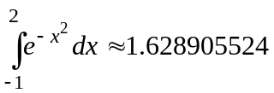

█

Example 8: Evaluate 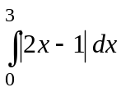
Solution: Note that 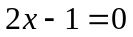 when 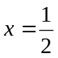. Thus, when 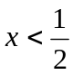, 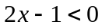 and when 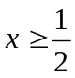, 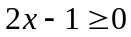. Since the absolute value of a quantity is always positive, we can say by the definition of the absolute value that

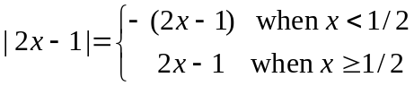
Thus, we can say that

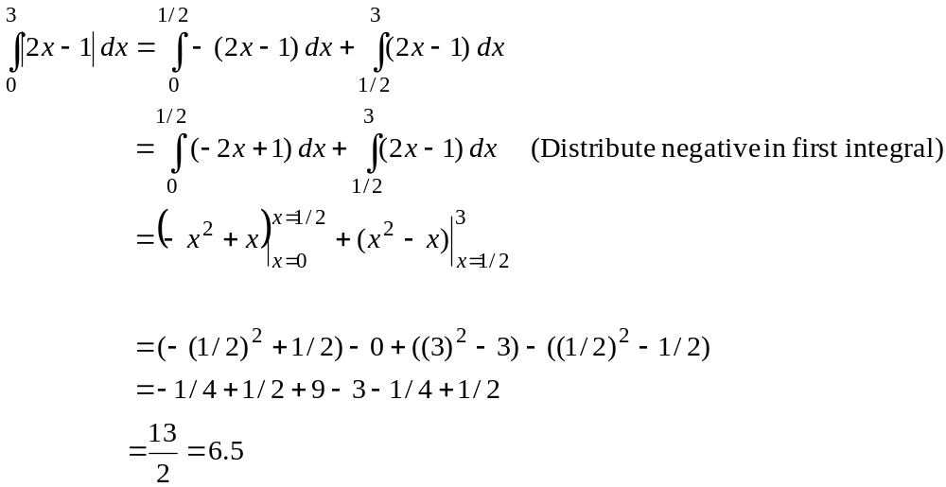
█
Note: For a function f (x) that is both positive and negative over an interval, the total area is the area enclosed by the positive part of the curve minus the negative part of the curve.

Example 9: Consider the function 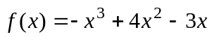 over the interval 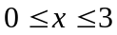. The graph of the function over this interval is given by

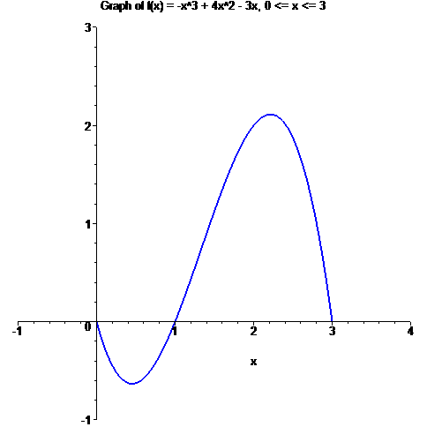

Find the total area enclosed between the function and the x axis.

Solution:

█
Average Value of a Function

The average value of a function measures the average value (average y value) for a function over a closed interval. Its formula is given as follows.

Formula for Average Value of a Function

If a function f is integrable on a closed interval [a, b], then

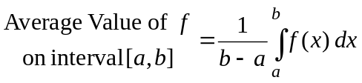

Example 10: Find the average value of the function 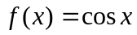 on the interval 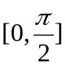.

Solution: For this problem, 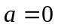 and 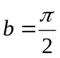. Thus, the average value is given by

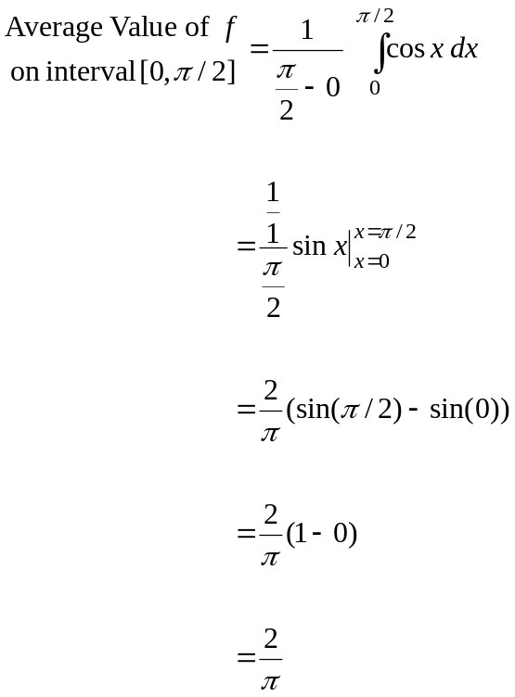

█
The Second Fundamental Theorem of Calculus

If f is continuous on an open interval I containing a, then for every x in the interval

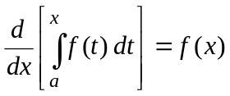

Example 11: Using the Second Fundamental Theorem of Calculus to find 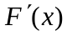 if

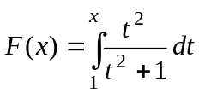

Solution:

█

Recall that the chain rule of differentiation was used to differentiate a composition of two functions. The formula for the chain rule was given by:

Chain Rule of Differentiation

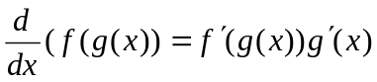

Suppose we let 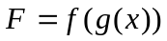 and let 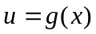. Then 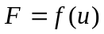 and hence

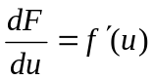 and 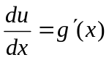

For and we can use these ideas to rewrite the chain rule as follows:

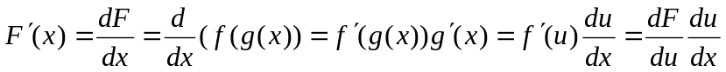

This gives another way to write the chain rule, which we summarize as follows:

Chain Rule: Alternative Form

If we want to differentiate the composition 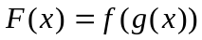, we set and compute the following:

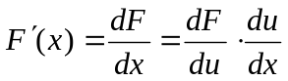

For example, suppose we want to differentiate

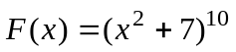

Then by setting 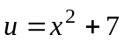, we have

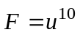

Hence,

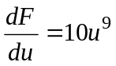 and 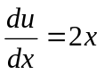.

Thus, for

.

This way of expressing the chain rule can be useful when using the Second Fundamental Theorem of Calculus. Suppose

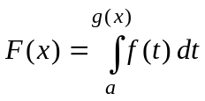

Then setting gives
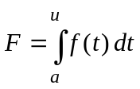

Then

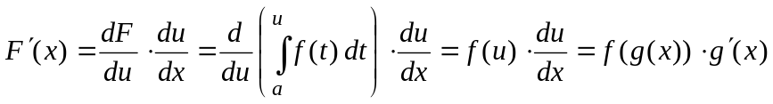

Example 12: Using the Second Fundamental Theorem of Calculus to find if

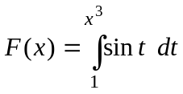

Solution:

█

Example 13: Using the Second Fundamental Theorem of Calculus to find if

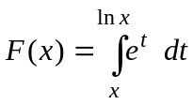

Solution: We start by rewriting the integral as follows:

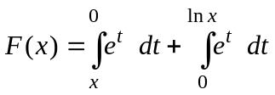

Next, we can use the property of integration where

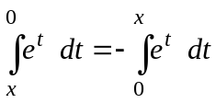

Thus, the integral becomes

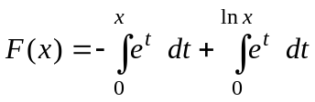
Hence,

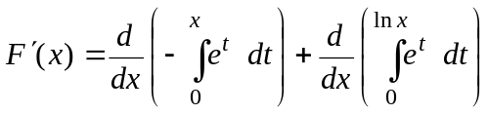

The first term in the sum we can use the Second Fundamental Theorem directly and write:

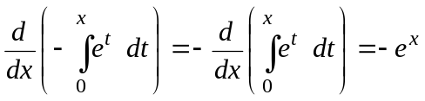

For the second term in the sum 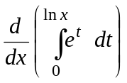, we write 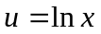 (note 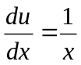). Then 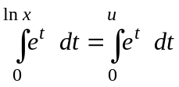 and we can write (continued on next page)

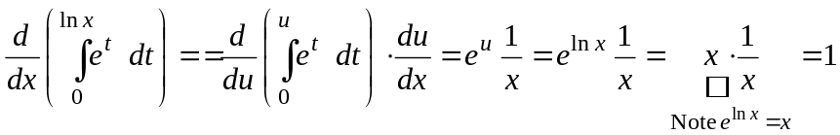

Hence, 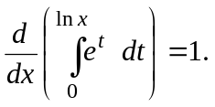 Using the fact we calculated above that 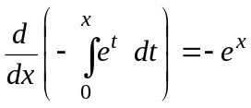, we have





