Supplemental Section: Trigonometry

Angle Measurement

Angles can be measured in degrees.

Counterclockwise Angles Clockwise Angles
x
y
x
y

Important Degree Relationships
y
1 revolution = 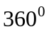
 revolution = 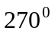
 revolution = 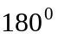
 revolution = 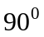
x

Angles can also be measured in radians.

Consider the unit circle
y

x

Important Radian Relationships
y
1 revolution = 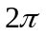 radians
revolution = 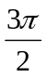 radians
revolution = radians
revolution = 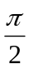 radians
x

Example 1: Draw, in standard position, the angle 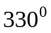

Solution:

█

Example 2: Draw, in standard position, the angle 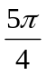.

Solution:

█
Angle Measurement Conversions

Formula for converting from degree to radian measure

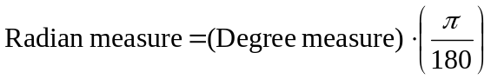

Formula for converting from degree to radian measure

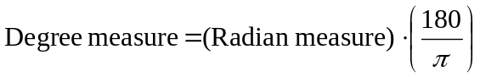

Example 3: Convert 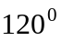 from degrees to radians.

Solution:

█

Example 4: Convert 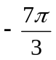 from radians to degrees.

Solution: Using the formula
we obtain the result

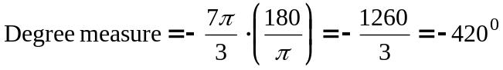

█

The Sine and Cosine Functions

We can define the cosine and sine of an angle in radians, denoted as 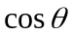 and 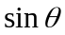, as the x and y coordinates respectively of a point P on the unit circle that is determined by the angle .

Consider the unit circle
y

x

Sine and Cosine of Basic Angle Values

Degrees | Radians
0 | 0
30 | 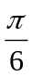
45 | 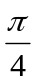
60 | 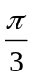
90
180
270
360

Note: If we know the cosine and sine values for an angle in the first quadrant, we can determine the sine and cosine of related angles in other quadrants.

Sign Diagram for Cosine and Sine Values

y
x

Example 5: Compute the exact values of the sine and cosine for the angle 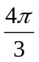

Solution:

█

Example 6: Compute the exact values of the sine and cosine for the angle 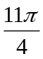.

Solution:

█
Other Trigonometric Functions

Tangent: 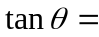 Secant: 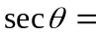

Cosecant: 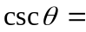 Cotangent: 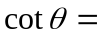

Example 7: Find the exact values of the six trigonometric functions for the angle 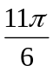.

Solution:

█

Note: 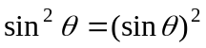, 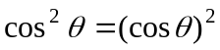

Basic Trigonometric Identities

Pythagorean Identities Double Angle Formula
1. 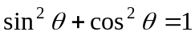 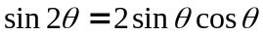
2. 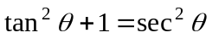
3. 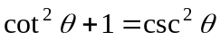

Example 8: Find the values of x in the interval 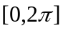 that satisfy the equation 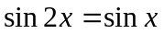.

Solution: We solve the equation using the following steps:

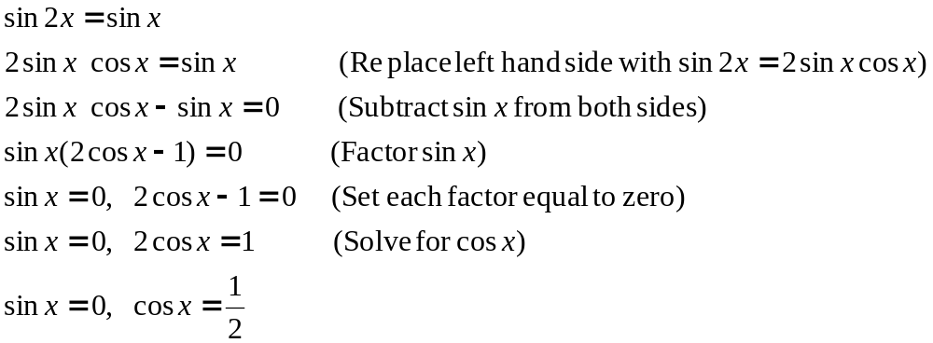

In the interval , 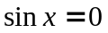 when 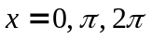. In the interval , 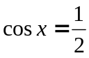 when 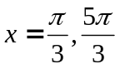. Thus the five solutions are

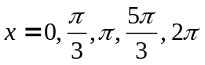

█

Graphs of Sine and Cosine

Period – distance on the x axis required for a trigonometric function to repeat its output values.

The period of 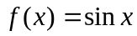 and 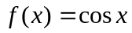 is.

Example 9: Graph

Solution: The graph can be plotted using the following Maple command:

> plot(sin(x), x = -4*Pi..4*Pi, y = -2..2, color = red, thickness = 2);

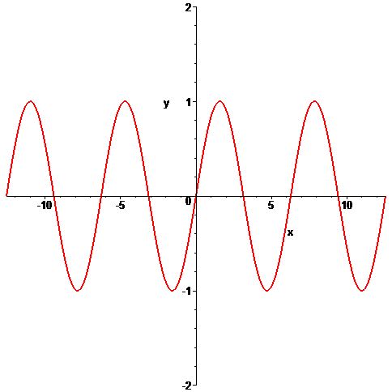

█

Example 10: Graph

Solution: The graph can be plotted using the following Maple command:

> plot(cos(x), x = -4*Pi..4*Pi, y = -2..2, color = red, thickness = 2);

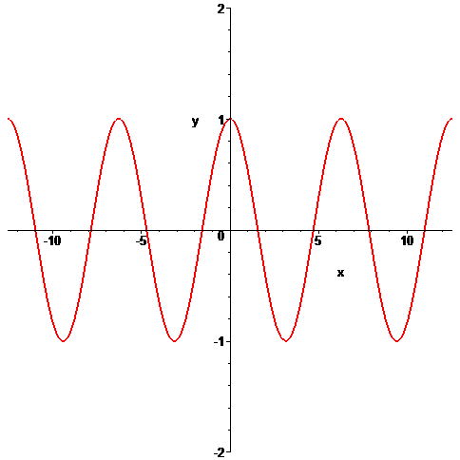

█
Graph of the Tangent Function

Period of the tangent function is radians. The vertical asymptotes of the tangent function 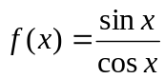 are the values of x where 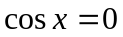, that is the odd multiples of , 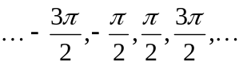.

Example 11: Graph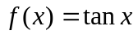.

Solution: The graph is given by the following:

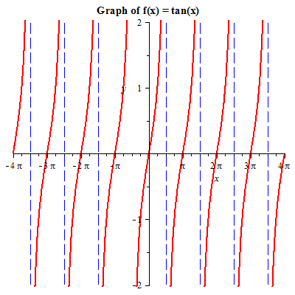

█
Practice Problems

1. Convert from degrees to radians.
a. 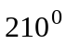 c. 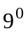
b. 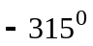 d. 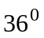

2. Convert from radians to degrees.
a. 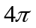 c. 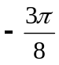
b. 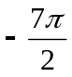 d. 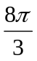

3. Draw, in standard position, the angle whose measure is given.
a. c. 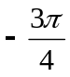 rad
b. 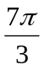 rad d. 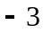 rad

4. Find the exact trigonometric ratios for the angle whose radian measure is given.
a. 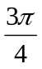 c. 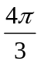
b. d. 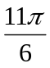

5. Find all values of x in the interval 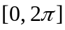 that satisfy the equation.
a. 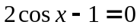 b. 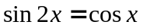

Selected Answers

1. a. 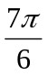, b. 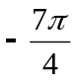
2. a. 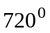, b. 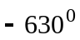

4. a. 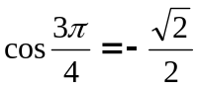,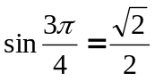, 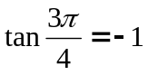, 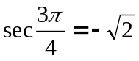, 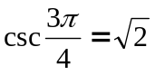, 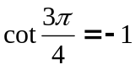
b. 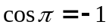,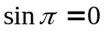, 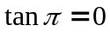, 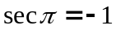, 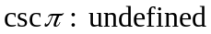, 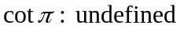

5. 

