Supplemental Problems for Section 1.4

Recall the following:

Vertical Shift and Stretch Summary
Given 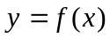 and a positive number c. Then
1. 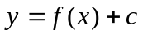 shifts the graph 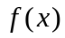 up c units (adds c to all y coordinates of ).
2. 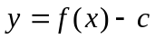 shifts the graph down c units (subtracts c from all y coordinates of ).
3. 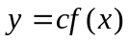 stretches the graph of up by a factor of c (multiplies all y coordinates of by c).
4. 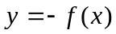 reflects the graph of across the x-axis (multiplies all y coordinates of by 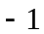).

Horizontal Shift and Stretch Summary
Given and a positive number c. Then
1. 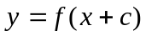 shifts the graph left c units (subtracts c to all x coordinates of ).
2. 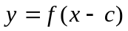 shifts the graph right c units (adds c from all x coordinates of ).
3. 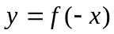 reflects the graph of across the y-axis (multiplies all x coordinates of by ).

Example 1: For the exponential function 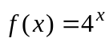 , write the resulting equation from
a. shifting 5 units downward.
b. shifting 1 unit to the right.
c. reflecting about the x-axis and then the y-axis.

Solution:

█

Example 2: For each of the following, find the base b if the graph of 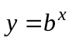 contains the following points.
a. 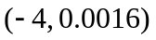
b. 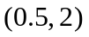
c. 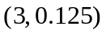

Solution:

█

Example 3: Solve the equation 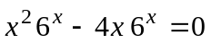 for x.

Solution: Here, we start by factoring the common term 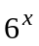 to obtain

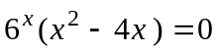

Since 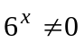 for any value of x, we divide both sides by to obtain

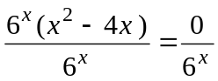
or
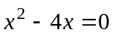.

Hence, we can solve for as follows

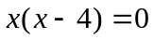

which gives to solutions of 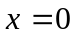 and 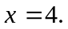 █

Example 4: Solve the equation 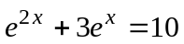 for x.

Solution:

█
Definition: We say that the logarithm of base b of x, which is denoted as

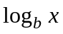, where 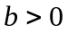 and 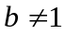

is the exponent b must be raised to obtain x. That is

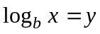 means 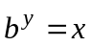

Example 5: Evaluate the following:
a. 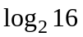
b. 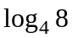
c. 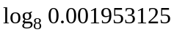

Solution:

█
Change of Base Formula for Logarithms

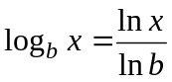

Example 5: Approximate 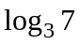

Solution:

█

Inverse Properties of Logarithms

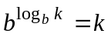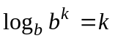

Example 6: Solve the resulting equation 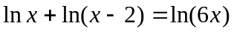 for x.

Solution:

█
Example 7: Solve the resulting equation 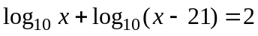 for x.

Solution: We can solve this equation using the following steps

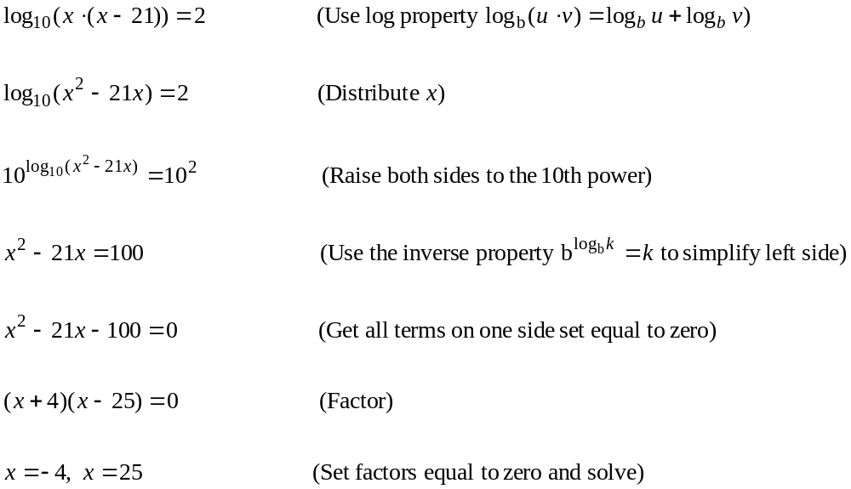

However, we can see that solution 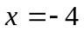 would be a false (extraneous) solution since this would require in the original equation that

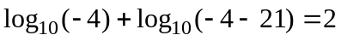

However , 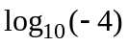 is undefined. Thus the only solution is

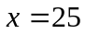

█

Fact: Since the natural logarithm is an increasing function, if 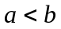, then it follows that 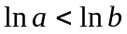

Example 8: Find the smallest integer that satisfies the inequalities
a. 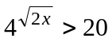
b. 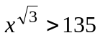

Solution:

█

