Section 2.5: Implicit Differentiation

Practice HW from Larson Textbook (not to hand in)
p. 131 # 1-47 odd, 65-73 odd

Implicit Functions

Most functions we have seen have been written in the form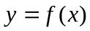. When we solve for y and get an expression solely in terms of x, we say that y is said to be an explicit function of x.
Examples of Implicit Functions: 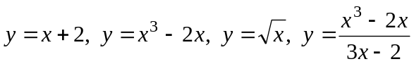.

We can also relate x and y implicitly.

Consider 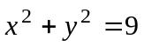. Here y is said to be an implicit function of x.

To make this an explicit function, we solve for y.

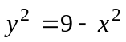

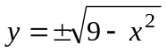

Get two explicit functions, 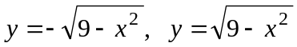.

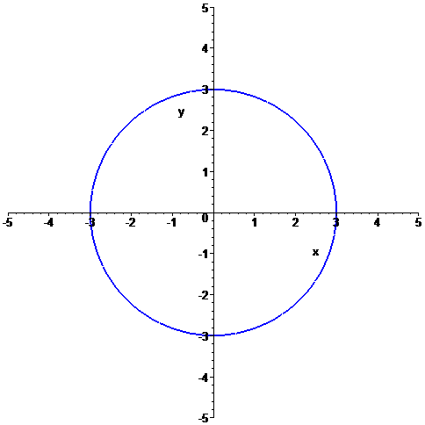
Differentiating Implicit Functions

Here we use that fact that y is assumed to be a function of x.

If , then

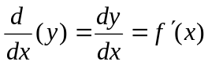

For 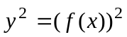, we see that

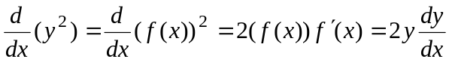

Similarly, we can say that
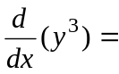
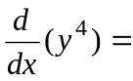

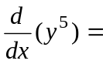

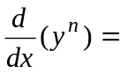

Informally, to differentiate an implicit function.
1. Take the derivative of the “x” like you have always done before using the basic derivative formulas.

2. To take the derivatives of the “y” terms, differentiae the y term using a basic differentiation formula and always multiply the result by 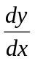.

3. Solve for .
Example 1: Find if and interpret the meaning of the derivative.

Solution:

█

Example 2: Differentiate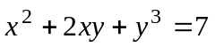.

Solution:

█
Example 3: Differentiate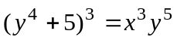.

Solution:

█

Example 4: Differentiate 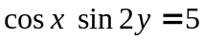.

Solution: The following shows the steps for computing 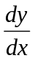:

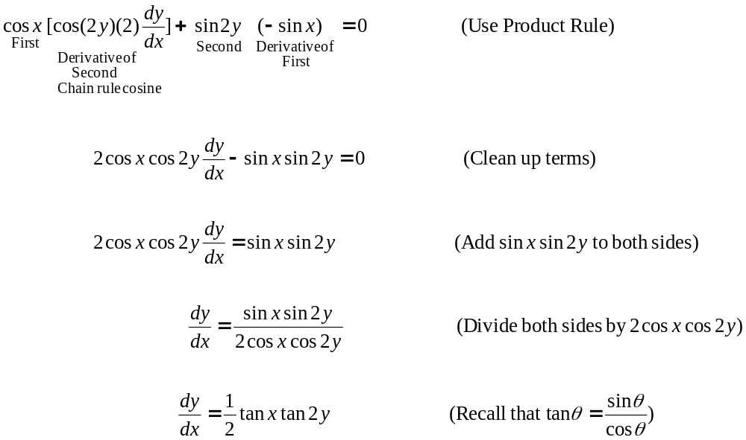

█
Example 5: Find the equation of the tangent line to the curve 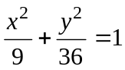 at the point 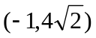.

Solution: To find the equation of the tangent line, we need its slope and a point on the line. The point is given so we first must find the tangent line slope. Recall that the slope of the tangent line is found by finding the derivative 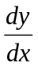, which in this example we must find by implicit differentiation. Thus, we have

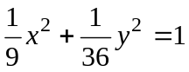 (Use fact that 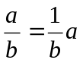 to rewrite in an easier
form to differentiate )

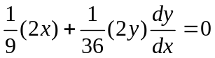 (Differentiate both sides)

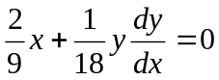 (Simplify)

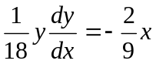 (Isolate term)

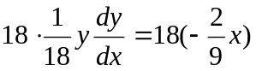 (To solve for , multiply both sides by 18)

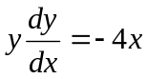 (Simplify fractions in previous step)

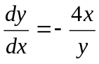 (Divide both sides by y to solve for )

To find the tangent line slope, we must substitute the point into . Note here that both the x and y coordinates of the point are required. Thus, we obtain

Continued on Next Page
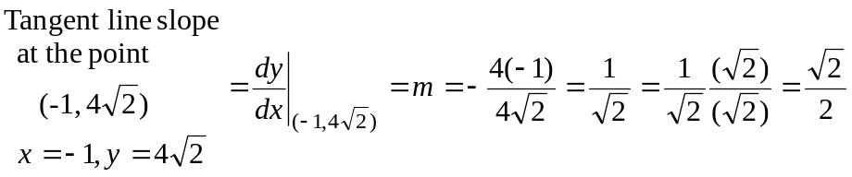.

Using the slope intercept equation of a line 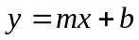, we now write the equation of the line as follows:

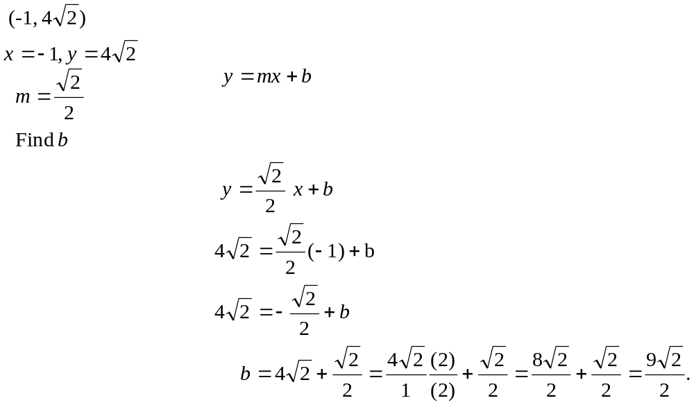

Thus, the tangent line equation is 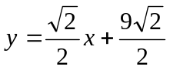.
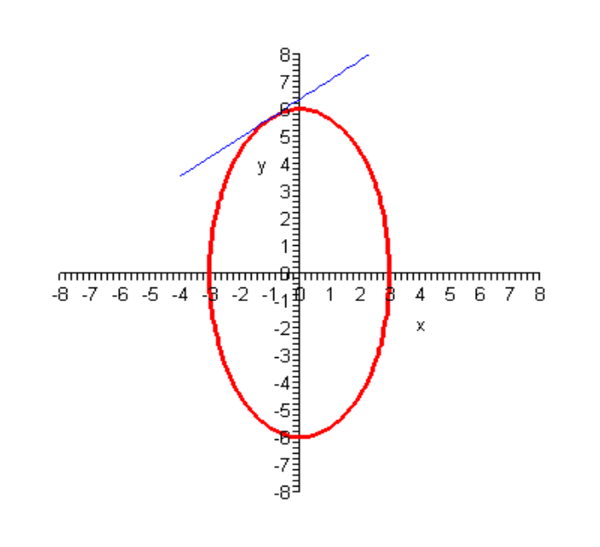
Logarithmic Differentiation

Gives a way of simplifying functions using logarithms into a form where the derivative can be computed.

Steps for Logarithmic Differentiation

1. Take the natural logarithm of both sides of the equations. Then simplify the right hand side of equations using properties of logarithms
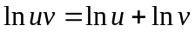
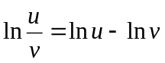
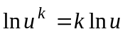

2. Differentiate both sides of the equation.
3. Solve for the derivative .

Example 6: Use logarithmic differentiation to differentiate the function 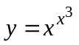.

Solution:

█

Example 7: Use logarithmic differentiation to differentiate the function 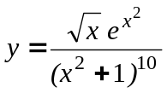.

Solution: We start by taking the natural logarithm of both sides and simplifying the right hand side using the basic logarithm properties:

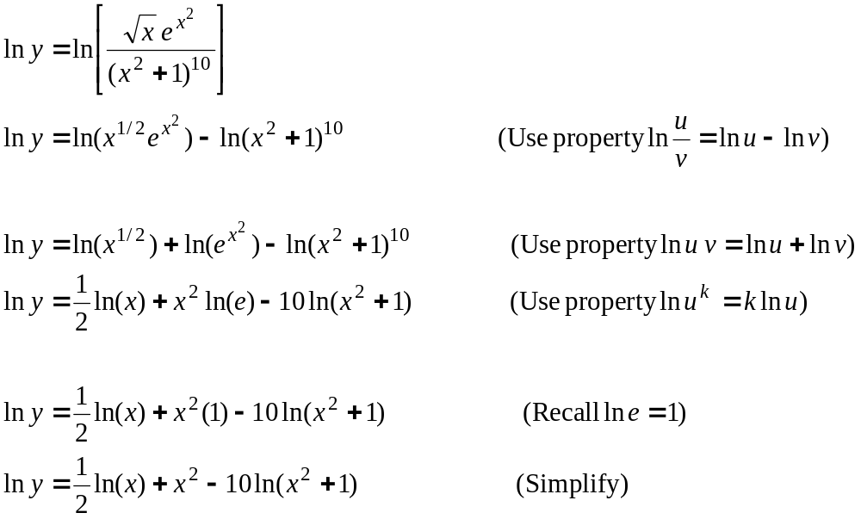

Differentiating both sides and simplifying gives

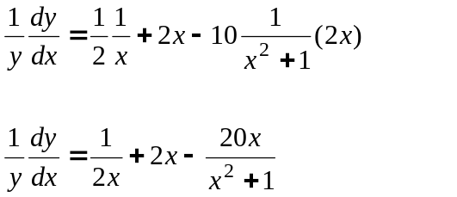

Solving for and replacing y with its original formula gives the solution




