**MOTION ON FACULTY SENATE PRESIDENT’S TERM ON THE BOARD OF VISITORS**

**Referred by: Governance Committee**

**MOTION**The Faculty Senate recommends the following changes to the *Constitution* of the Radford University Faculty Senate.

*Current Language:*

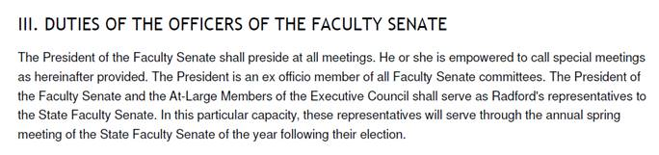

*Proposed Addition (add to end of Section V):*

The President of the Radford University Faculty Senate shall serve as faculty representative on the Board of Visitors. For a newly elected president elected during the initial Senate organizational meeting, his/her term as the faculty representative on the Board of Visitors shall begin on July 1 following their election. The Faculty Senate President shall serve no more than two consecutive terms as faculty representative to the Board of Visitors. If the same individual serves more than two terms as Faculty Senate President, the faculty representative to the Board shall be appointed from a list of three faculty members submitted to the Board of Visitors by the Faculty Senate. Should the faculty representative resign as Faculty Senate President during his/her term on the Board of Visitors, the new senate president shall fill the remaining term on the Board of Visitors for the individual who resigned. In the event that an individual assumes the role as faculty representative on the Board of Visitors for a period of 180 days or more, that period will count as one full term on the Radford University Board of Visitors.

**RATIONALE**These changes are being made to ensure the Constitution is consistent with the revised By-Laws of the Board of Visitors. In addition, the changes create continuity of representation to the BOV by ensuring that the term of the Faculty Senate President coincides with the term of other members of the Board of Visitors (that is, it begins on July 1). A Senate President who is elected in late April or early May cannot be expected, if she or he is new to the position, to represent the faculty at the May meeting of the Board of Visitors.