**MOTION REVISING SECTION II OF FACULTY SENATE CONSTITUTION**

**Referred by: Governance Committee**

**MOTION**The Faculty Senate recommends the following changes to the *Constitution* of the Radford University Faculty Senate to remove duplicate language in Section II.

*Current Language:*

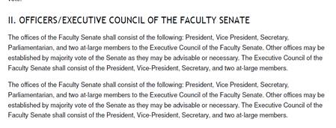

*Proposed Revision (eliminate duplicate paragraph):*

The offices of the Faculty Senate shall consist of the following: President, Vice President, Secretary, Parliamentarian, and two at-large members to the Executive Council of the Faculty Senate. Other offices may be established by majority vote of the Senate as they may be advisable or necessary. The Executive Council of the Faculty Senate shall consist of the President, Vice President, Secretary, and two at-large members.

**RATIONALE**The change is necessary to remove duplicate language.