Recommended Standard for Preferred Names

At the Banner Operations Committee meeting, the following data standards were approved for names. These will be updated in the official data standards documents but I wanted to make sure that we all know about them and work toward compliance with the standards.

Banner will store the person legal name in the spriden_first_name, spriden_mi, and spriden_last_name. These are the first three fields in the Person block on spaiden or ppaiden.

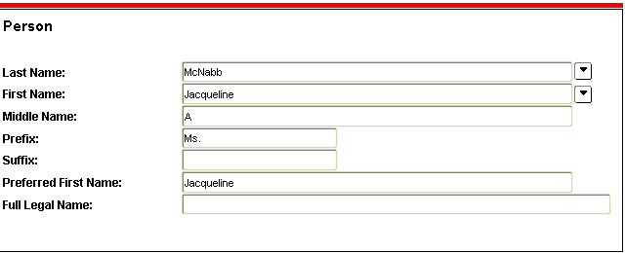

If the person has communicated a “Nick Name” or what they like to be called, this will be entered into the preferred name field on the person block in spaiden or ppaiden and stored in spbpers_pref_first_name. Currently it looks like the conversion may have put all first names into preferred name as well. A script will be written to purge the ones that are an exact match of their first name. Also changes will be made to allow the preferred name to be changed in SSB from the personal info channel in MyRU.

In Self Service Banner, the class rosters and class schedules and the campus web directory will be enhanced to display both first name and preferred name in the following manner:

Smith, Michael (Mike) or Michael (Mike) Smith

Name information is pushed to other systems on campus. If the system allows for a first name and a preferred first name then both should be sent. If the system only allows for one first name then it will be the legal name.

