Radford University Institutional Review Board (IRB)

Step-By-Step Faculty Instructions for Completing CITI IRB Training Modules*

When Registering As a New User on CITI
- Go to www.citiprogram.org. New users should select “Register Here”. (See screenshot #1 below.)
- List Radford University as your affiliated institution using the drop-down menu next to “Participating Institutions”. (See screenshot #2 below).
  - Skip the remaining drop-down menus in Question 1.
- Continue answering the remaining questions including creating a username, password, and entering your profile information. (Your RU username and password will NOT work in CITI or IRBNet).
  - Select “No” on Question 6 regarding CME/CEU credits.
  - Click “Submit” at the bottom of the screen to continue.
- When selecting your curriculum for training modules, choose the “Social & Behavioral Research Investigators” module from Question 1. (See screenshot #3 below).
- Select “Continue” from the bottom of the screen when you are finished to be taken to the main menu.
If Currently Registered on CITI, but not enrolled in Course Modules
- Log on to www.citiprogram.org with your CITI username and password that you created when you created your CITI account. You will then be taken to the main menu (see screenshot #4 below).
- Make sure that you are affiliated with Radford University. If you are not, select “Affiliate with another institution” from the main menu. (See screenshot #4, red arrow.) Select Radford University from the drop-down menu of “Participating Institutions” in the resulting screen and click “Submit” to return to the main menu. (See screenshot #2.)
  - Tip: Type the letter R or the first few letters of “Radford” to jump down to Radford University.
  - Skip the remaining drop-down menus in the section.
- Make sure that you have enrolled for the “Social & Behavioral Research Investigators” module
  - If you have not selected the appropriate course, select “Add a course or update your learner groups” from the main menu. (See screenshot #4, green arrow.) Select “Continue” from the bottom of the screen to return to the main menu after choosing your module in Question 1. (See screenshot #3.)
To Complete Courses
- From the main menu, begin completing the module by selecting “Enter” under the status column for the desired module. (See screenshot #4, purple arrow.)
- You must obtain a total score of 80 for all topics to pass the module. Select a topic by clicking on its hyperlink. (See screenshot #5 below.)
- NOTE: The Integrity Assurance Statement may appear randomly at the start of new sessions when completing a module over several sessions. You must click on it and respond to it prior to being allowed to resume completing the course. (See screenshot #5, green circle.)
- Upon completing a module, you do NOT need to print a certification of completion. This is not required for IRB submissions as the RU IRB Office can view your scores via the CITI database.
  - However, you may print a certificate of completion by selecting “print” next to your desired module on the main menu screen. It will indicate the date and grade of the module if you desire (see screenshot #7 below).
* All Human Subjects Trainings are valid for a period of three years.
Screenshot #1- Registering on CITI
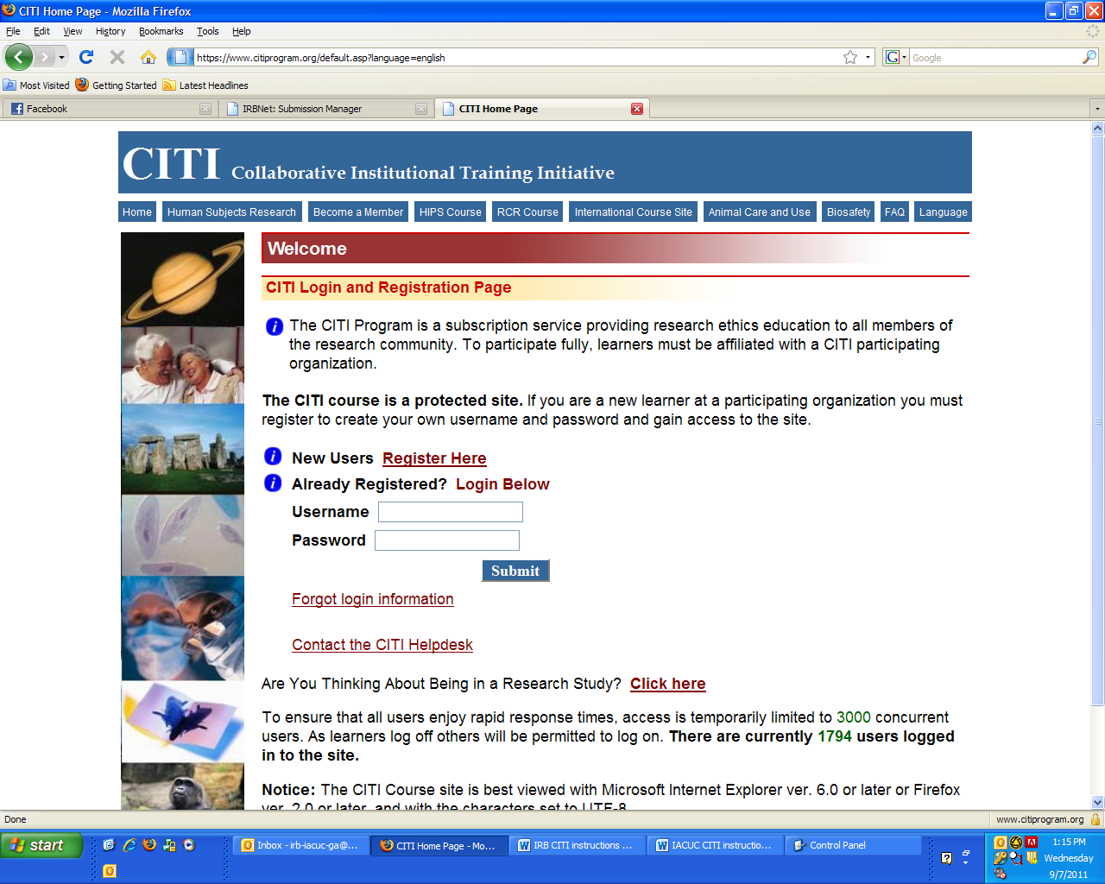
New users should begin their registration process at www.citiprogram.org. Select “Register Here” to begin selecting your profile information.

Screenshot #2- Selecting your Institution or Organization
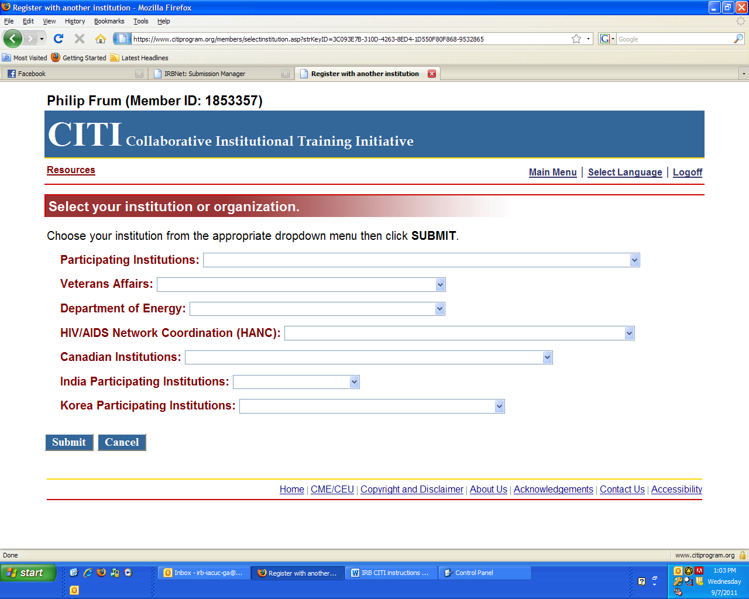
Select Radford University from the drop-down menu on this screen.
- TIP: Type the letter R or the first few letters of “Radford” to jump to Radford University.
- Skip the remaining drop-down menus in this section.
- Select “NO” when prompted about CME/CEU credits.
Additionally, this screen may be shown a 2nd time after entering your profile information while registering on CITI to allow you to affiliate with additional institutions if you desire. If you have already registered on CITI, this will only appear by selecting “Affiliate with Another Institution” on the main menu.

Screenshot #3- Selecting Your Modules
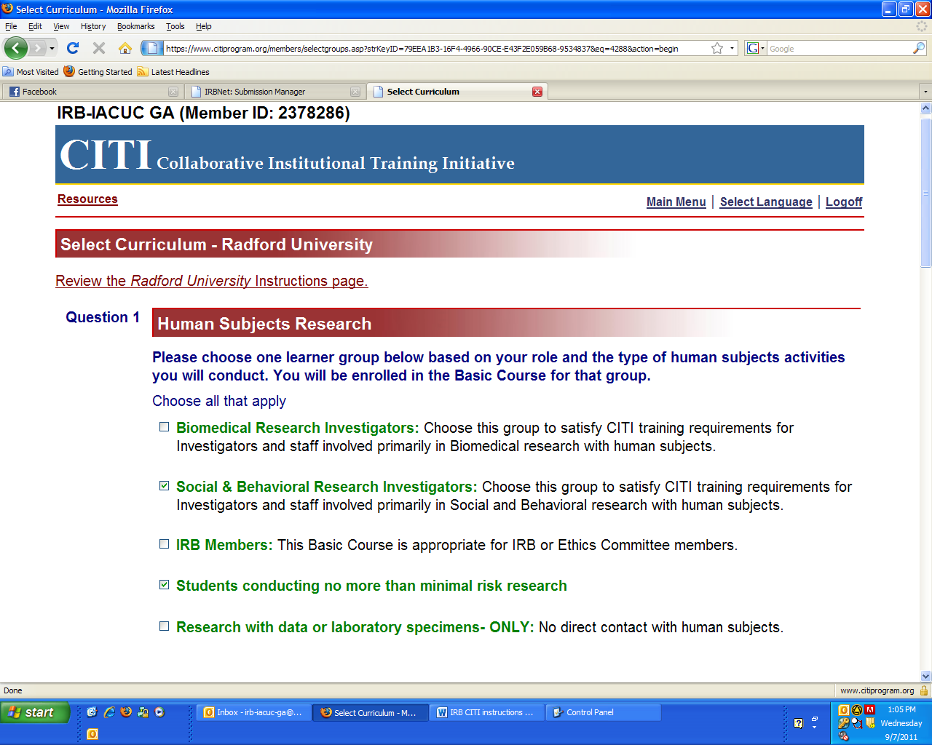
All IRB required modules are located in “Question 1, Human Subjects Research” of the “Select Curriculum” page. Select the “Social & Behavioral Research Investigators” module.

Screenshot #4- Navigating the Main Menu
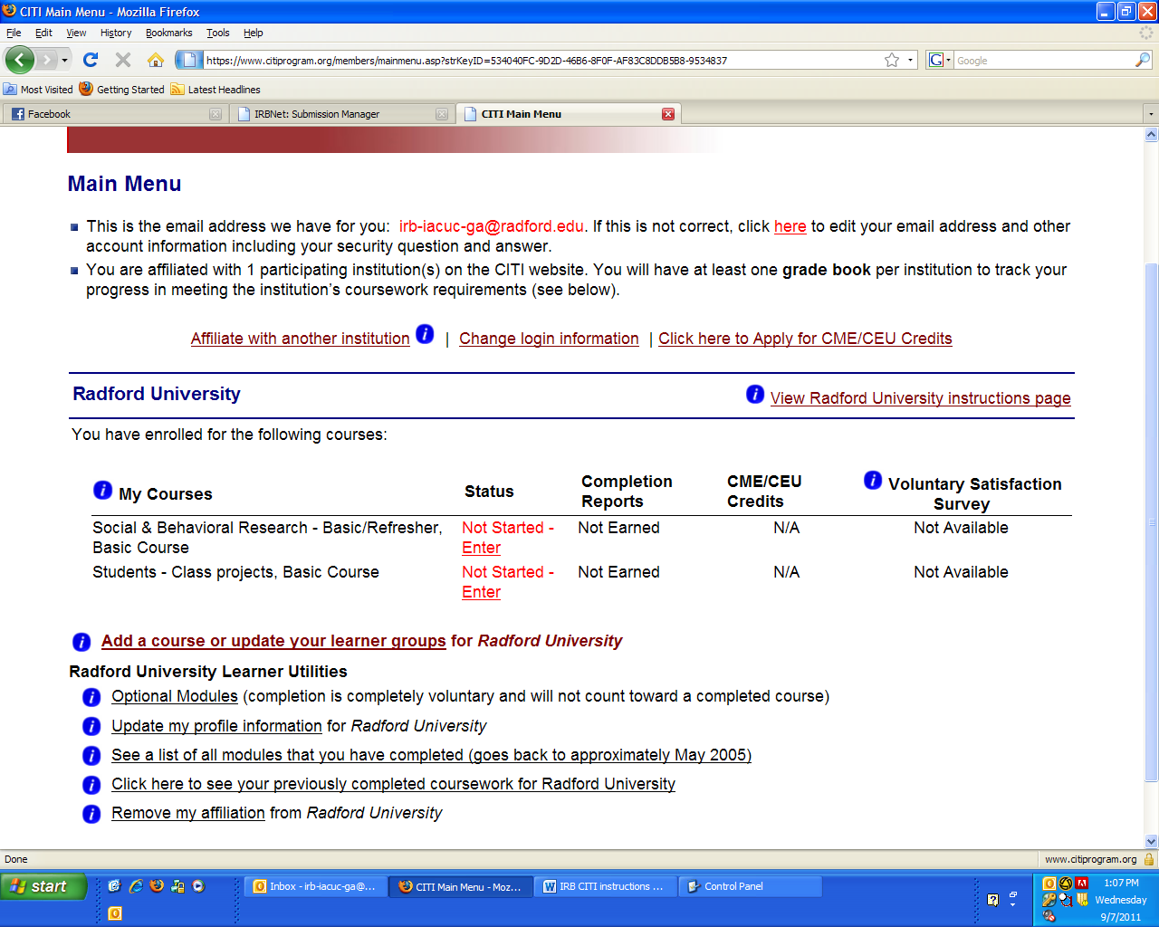
The main menu allows for various options for compliance training. You can choose to affiliate with Radford University or other institutions if you have already registered on CITI (red arrow). You can enter and complete your enrolled modules (purple arrow). You can also add additional modules to complete (green arrow, also see screenshot #3).

Screenshot #5- Choosing a Topic From Your Course Module
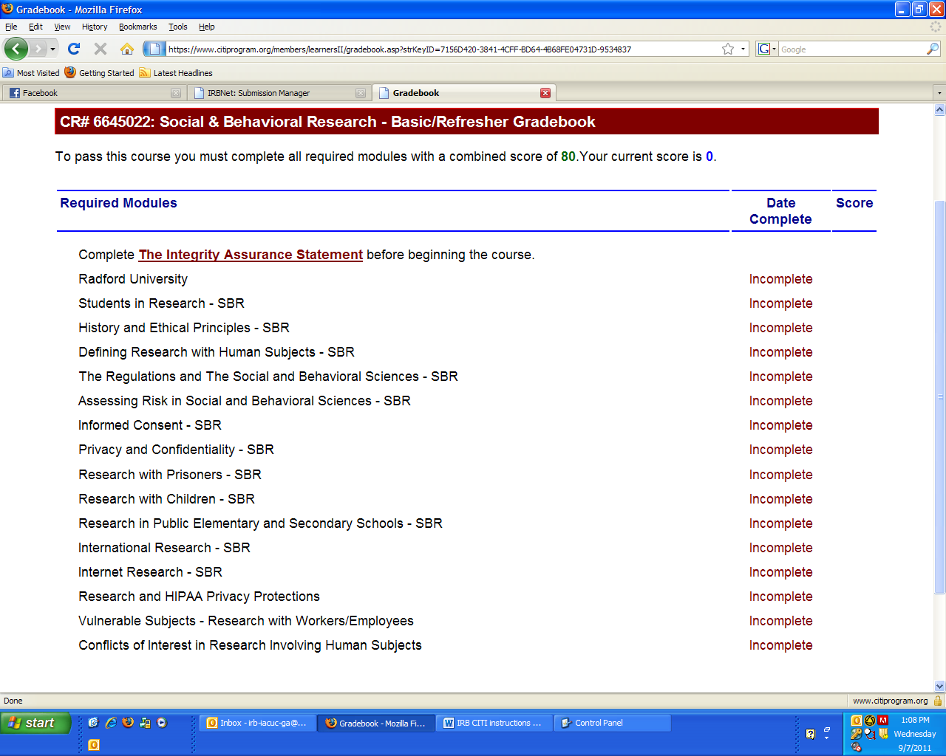
Once you have selected your desired module, you can complete each topic by clicking on its hyperlink. You may start and stop during modules at any time. Additional topics will be available for a module once you have completed the “Integrity Assurance Statement” at the beginning of each module.
NOTE: This assurance statement may appear at random intervals when returning to an incomplete module or course and must be completed each time it appears. This is CITI’s method of validating users and is not something that RU can affect.

Screenshot #6- Example Quiz to Complete in CITI
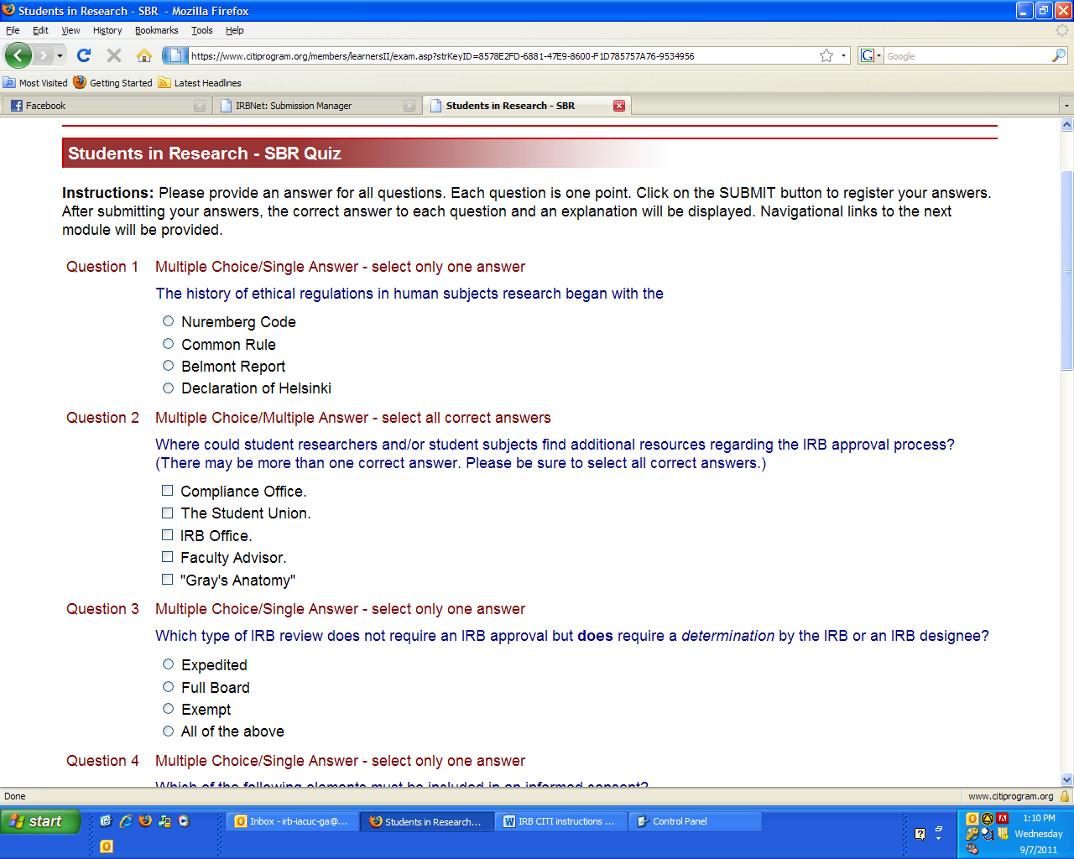
Most topics require a short quiz to be completed at the end of its readings. You must obtain a total score of 80 for all topics to complete the module. Topics and quizzes can be retaken until the course is complete.

Screenshot #7- Printout of Certificate
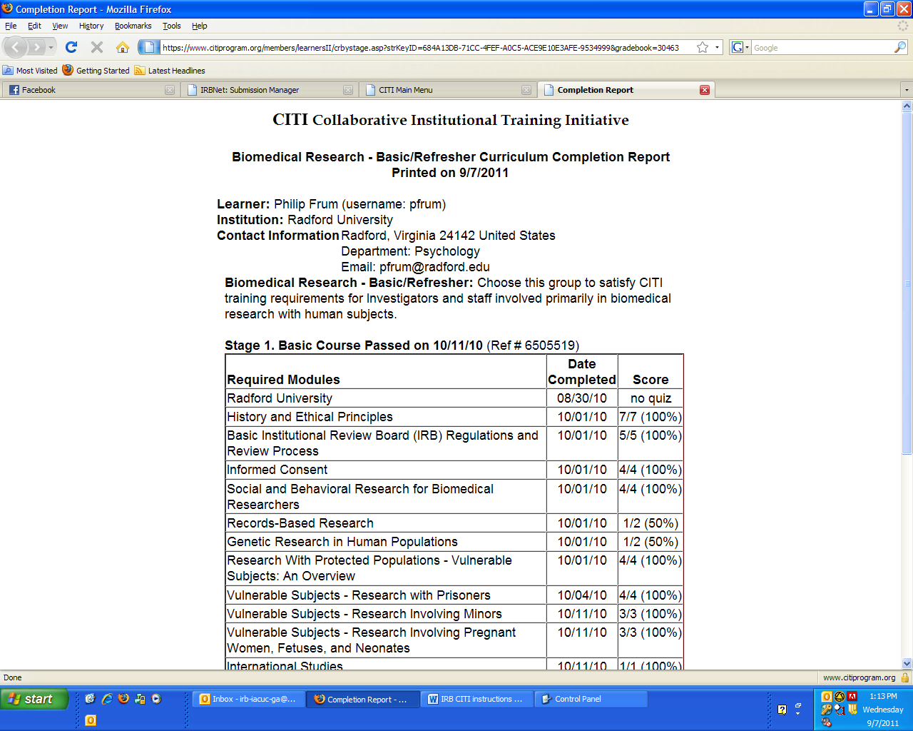
You will see this completion certification when you have passed your course but it is not necessary to print it. The RU IRB Office is able to view this certification in the CITI database, but a certificate can be printed out for a completed module by selecting “Print” next to the desired module on the main menu for your records, if you desire. Keep in mind that training certificates expire after 3 years of completion.

