How to Schedule a Testing Appointment
RUC Educational Testing Center (ETC)

- Log in to your OneCampus.
- Click on the Starfish tile.
- Ensure you are in “My Success Network.”
- Scroll down to the “Educational Testing Center (RUC)” and select “Schedule.” (If you are a student with accommodations, choose “CAS Testing at RUC.”)

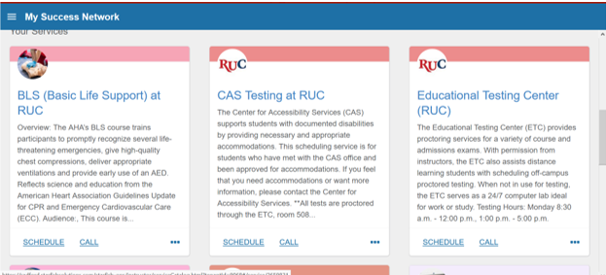

- Select which time duration you would like and click the blue “Continue” button.

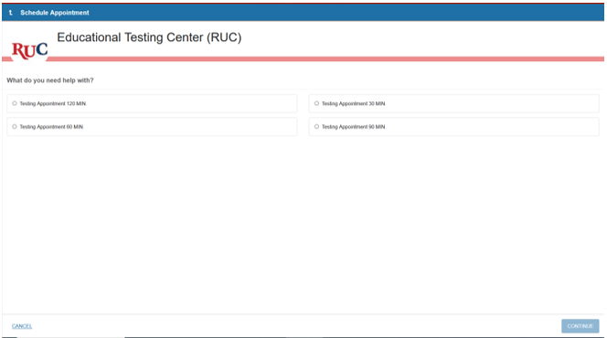

- In the upper left-hand corner, select the month you would like to test via the arrow buttons. Then click on the date, regardless of boxes or bolding. Use the scroll bar to select times available on that date. Select “Continue.”

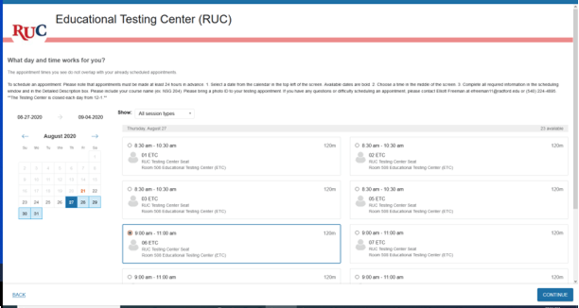

- Ensure the date and time listed in the upper left corner are correct. In the box at the right, include your instructor’s name, course code, and name of test. Press “Confirm.”

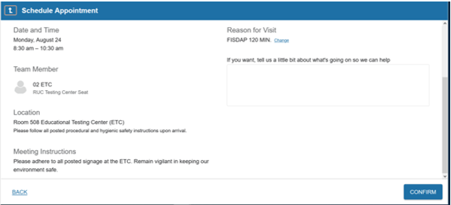

- After submitting your request, you will receive an email from Starfish confirming your appointment.

Appointments must be scheduled at least 24 hours prior to testing.
If there are no time slots for the time and date desired, additional appointments may be available.
Email ruc-etc@radford.edu or call the ETC at 540-224-4895.

