RESOURCE REPORT D
SKILLS EMPLOYERS WANT IN ANALYTICS FOCUSED HIRES
Job postings for analytics positions on LinkedIn were examined to determine the skills sought by employers for Analytics focused applicant. There were 121,842 job postings on LinkedIn for Analytics positions between May 1, 2015, and June 4, 2015. Of these, 41,258 postings were for analytics internships, entry level, and associate level employees. Job requirement from a sample of 101 analytics jobs postings were compiled (see Resource Report B for listings of job postings used in this analysis). Requirements reflected two skill sets: Technical Competencies and Personal Traits and Abilities -- essentially the difference between requirements for hard skills versus soft skills. The educational requirements were broad, i.e., rarely was a single discipline required. Bachelor’s Degree in “Statistics, Business, Math, Finance, Economics, Marketing Research or other quantitative oriented fields” was required by 45% of job postings. Employers sought an MBA in 23% of the job postings. Employers sought a master’s degree in Statistics, Quantitative Management, Econometrics, or in Business with a heavy analytics focus or the equivalent in training/experience in 37% of the job postings.
Skills, Knowledge, and Abilities Expected of
Applicants for Analytics Positions
Technical Competencies In |  | Personal Traits and Abilities
Mention | Freq | Mention | Freq
SAS | 114 | Teamwork/working in teams/team skills | 97
Modeling/Predictive Modeling | 109 | Provide Solutions/Solve Problems | 91
SQL | 99 | Written, Oral, Verbal Communication Skills | 59
Segmentation | 72 | Collaborative/Collaboration | 57
CRM | 59 | Ability to Analyze/Analytical Skills | 49
Excel | 50 | Innovation/Innovativeness | 39
Mining/Data Mining | 47 | Presentation Skills | 31
SPSS | 32 | Passion/Passionate | 27
MS Word | 31 | Creative/Creativity | 27
Web/Google Analytics | 25 | independent discretion and judgment | 25
Multiple/Logistic Regression | 25 | Competence/Competent | 22
PowerPoint | 23 | Interpersonal Skills | 22
Oracle | 22 | Work Experience | 14
Access | 22 | integrity | 13
Tableau | 22 | Leadership/Leadership Skills | 9
R | 17 | Flexibility | 9
Decision Trees/CHAID | 15 | Curious/Curiosity | 8
Microsoft Office | 13 | Time Management Skills/Abilities | 8
Clustering | 12 | Applies Logic/Logical | 6
Cognos | 8 | Adaptive/Adaptable | 5
Teradata | 8 | Work Well Under Pressure | 5
Social Media | 7 | Critical Thinking | 5
Visual Basic | 6 | Ethics/Ethical | 4
Pivot tables | 5
STATA | 5
Java | 5
Crystal Reports | 4
Python | 3
Enterprise Miner | 3
C++ | 2
RapidMiner | 1

The Gartner Magic Quadrant for Advanced Analytics Platforms shows the importance of SAS, SPSS, SAP, and Microsoft. R, an open source programing-package shown on the chart as Revolution Analytics, has increasing recognition. Revolution Analytics, a.k.a. R went from being a Visionary in 2014 to being a Niche Player in 2015. The Center will provide training and workshops in R, but the clear industry leaders in 2014 and 2015 were SAS and SPSS.
2015 Magic Quadrant for Advanced Analytics Platforms
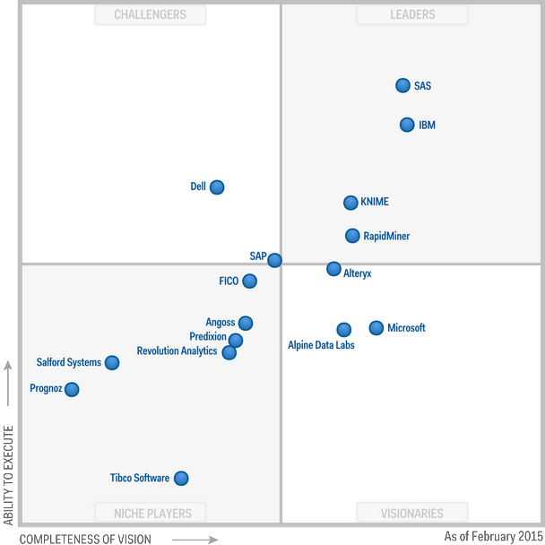
2014 Magic Quadrant for Advanced Analytics Platforms
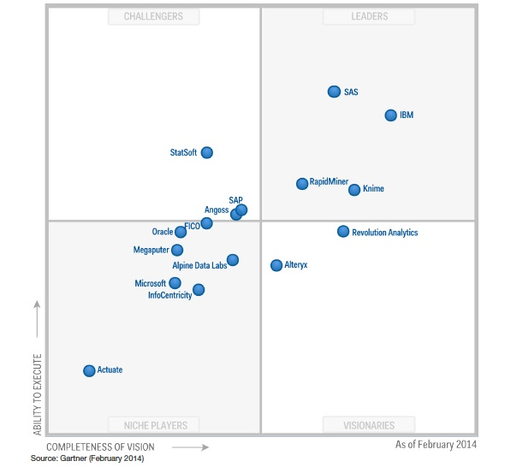

Regarding Business Intelligence (BI) and Analytics Platforms, SAS, SAP, IBM (who owns SPSS and Cognos), Tableau, Oracle, and Microsoft are clearly important companies/platforms. The Center will offer training, workshops, and other programs. These will provide all interested constituents an ability to gain or enhance the skills, knowledge and abilities needed to have successful careers in analytics or to work successfully with analytics professionals in creating a sustainable business.

2015 Gartner Magic Quadrant for BI & Analytics Platforms 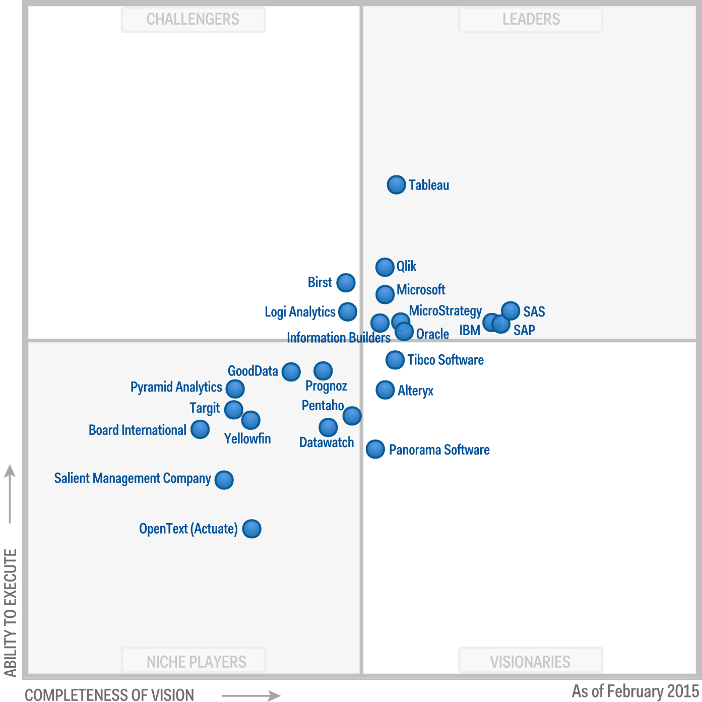
A visual summary of the skills, knowledge and abilities employers are seeking for analytics-related hires is shown in the word cloud depicted below:
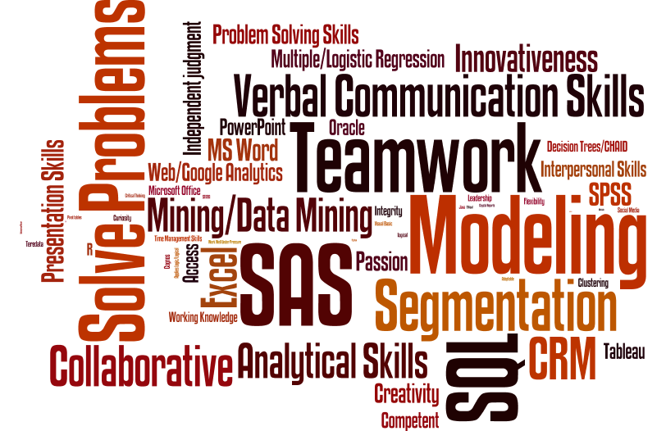

Gartner 2015 Magic Quadrant for Advanced Analytics Platforms: who gained and who lost. KDnuggets. Data Minin, Analytics, Big Data, and Data Science. (2015) http://www.kdnuggets.com/2015/02/gartner-2015-magic-quadrant-advanced-analytics-platforms.html
Gartner 2014 Magic Quadrant for Advanced Analytics Platforms – view report in KDnuggets (nd.) http://www.kdnuggets.com/2014/03/rapidminer-leader-gartner-2014-magic-quadrant-advanced-analytics-platforms.html ALSO found in Gartner Reveals Magic Quadrant for Advanced Analytics Daniel Gutierrez Inside Big Data (February 25, 2014) http://insidebigdata.com/2014/02/25/gartner-reveals-magic-quadrant-advance-analytics/
Op. cit. Gardner (2015)

