Summary Description
Roots with Wings
Floyd County Place-based Education Oral History Project
Intergenerational Community Connections in Floyd County, Virginia

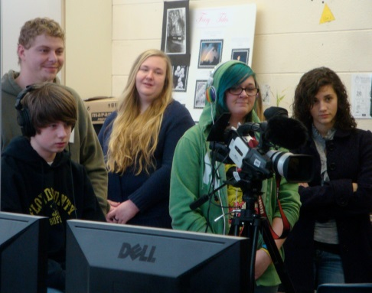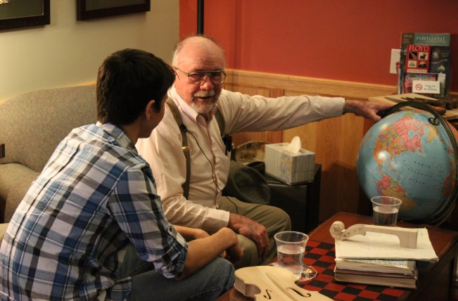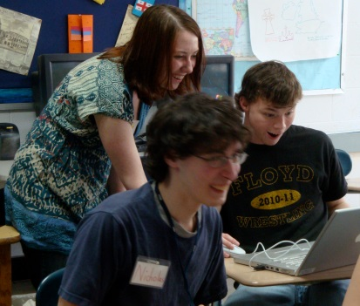
BUILDING SKILLS FORGING CONNECTIONS CONSERVING CULTURE

PROJECT: Research has shown that children who are most resilient in the face of challenges such as negative stereotyping, community and family dysfunction, or culture change have a “strong intergenerational self.” They know they belong to something larger than themselves. Youth taught to capture the wisdom of elders learn lessons of past hardships and absorb demonstrations of coping skills. The Project uses technology to foster these connections. As an ongoing initiative in the New River Valley, the Floyd County High School Place-Based Education Project has built a successful program on this model - forging connections, building technology skill levels, conserving history and fostering intergenerational understanding.

PARTNERS: The Radford University Appalachian Regional and Rural Studies Center, Center for Social and Cultural Research, and Scholar-Citizen Initiative partners with the Floyd Story Center and Old Church Gallery in Floyd County and with Floyd County High School for this mentor-based program to improve community connections, preserve cultural heritage, and build technology skills.

FOCUS: The Floyd County Place-based Education Oral History Project plants the roots of the “web of meaningful relationships” found to be a factor in community resilience. At the same time the Project affixes state-of-the-art technology wings. Radford University mentors work as part of an intergenerational team to teach high school students how to conduct ethical, methodologically sound interviews; record using state-of-the-art audio and video equipment; transcribe; create searchable tables of content; research historical background; archive; discover stories and themes in interviews; extract a theme from hour-long interviews; and create movies. Mentors come from a variety of majors and contribute by applying the special knowledge and skills learned in their coursework to the Project. The mentors may contribute to a 110-page Project Manual containing step-by-step instructions for carrying out the Project to high quality standards, and a Mentor’s Manual to prepare future mentors for their roles. The mentors complete requirements of internships in their particular majors.
OUTCOMES: What have the participants said?
HIGH SCHOOL STUDENTS:
- “Now, when I see someone as I walk down the street in town, I think, ‘I wonder what his story is.’” (At-risk student)
- “I learned that people of all ages can really work together to create a really cool project.”
- “It kind of opens your eyes to the world, and how it got the way it is now – you realize a lot more things that you didn’t realize – it’s really helpful.” (At-risk student)
- “This semester is one that I will remember for the rest of my life."
INTERVIEWEE:
- “I never imagined that anyone -- high school students, especially -- would be that interested in local people who had been in World War II. . . . I thank you very much for the program you put together. . . . [People should know] ‘War is hell.’” (Robert Nester, WWII Veteran)
RADFORD UNIVERSITY STUDENT MENTORS:
- “For me, I thought this was one of the best decisions I have ever made. Out of instinct I decided to take this course and I’m sure glad I did. I liked being able to relate to the high schoolers on a professional and personal level. Now, after the project, I feel like I can interact with students better and get my messages across clearly. I have learned valuable life lessons. I learned that helping people makes me about as happy as anything else in this world.” (Stephen Lesiv, Sociology)
- “My overall evaluation of the Floyd project is that it is a priceless experience. I am so grateful that I had a chance to be a part of something so wonderful. I got to use skills I learned in previous sociology classes, build new connections and friendships, realize what I want to do with my future, build lifelong memories, preserve precious history and be a part of something bigger than myself.” (Amy DuPont, Sociology and Counselor Education)
- “[The interviewees] provide a role model not only for the students doing the interviews, but to us as mentors as well. This project is important to me because I have always wanted to give back to the community, but never knew how. Now I know how I can give back and that is by helping these [high school] students learn the skills for success that we have learned. Not only do you get to meet new people and have great relationships, you get to change lives, and put smiles on faces. Most of all this project has made me a better person. It showed me that there is more to life than just being preoccupied with what I have going on in my life.” (Mike Barbour, Iraq War Veteran, Criminal Justice and Psychology)
FLOYD COUNTY HIGH SCHOOL TEACHER:
- “Through this project we give students connections. We give them the desire to connect in a new way to generations that have gone before them. My students are CHANGED!! They now have a sense of pride in completing this movie to HONOR their veteran. They don’t want to just get a grade. They want to give something back to these men and women -- something to give their children and grandchildren -- a way of knowing their family members in ways that they never would have known otherwise.” (Angela Via Meyers)
COMMUNITY PARTNER:
- “Know that I’ve personally gained much from the RU student collaborations. Each and every student has brought talent, thoughtfulness, and commitment to the project. The synergy couldn’t have been better!” (Kathleen Ingoldsby, Co-Director, Floyd Story Center)
EXTERNAL REVIEWER:
- “It sets a high standard as a model that other school and community oral history projects can follow. Floyd is fortunate to have this important part of its history saved and accessible to generations to come.” (Eileen McAdam, Director, Sound&Story Project of the Hudson Valley)

FOR MORE INFORMATION CONTACT: Dr. Melinda Wagner, mwagner@radford.edu;

See our blog: http://www.floydstorycenter.blogspot.com

Watch videos: http://www.youtube.com/watch?v=8hvQGrGMO1k; http://youtu.be/GwlCytc_IQs
https://www.youtube.com/watch?v=vfGucKIUXok; http://vimeo.com/95895720

See videos from and about the Project in Blue Ridge Country Magazine, on-line at:

http://blueridgecountry.com/videos/floyd_history/

http://blueridgecountry.com/videos/victoria-curtis/

